1 Kings 6 & 7
Read 1 Kings 6: 1-6: Solomon began to build the house of God; according to his father David’s desire. God never asked David to build a temple. It was an act of gratitude to God.
After the king was settled in his palace and the Lord had given him rest from all his enemies around him, ² he said to Nathan the prophet, “Here I am, living in a house of cedar, while the ark of God remains in a tent.” ³ Nathan replied to the king, “Whatever you have in mind, go ahead and do it, for the Lord is with you.” ⁴ But that night the word of the Lord came to Nathan, saying: ⁵ “Go and tell my servant David, ‘This is what the Lord says: Are you the one to build me a house to dwell in? ⁶ I have not dwelt in a house from the day I brought the Israelites up out of Egypt to this day. I have been moving from place to place with a tent as my dwelling. ⁷ Wherever I have moved with all the Israelites, did I ever say to any of their rulers whom I commanded to shepherd my people Israel, “Why have you not built me a house of cedar?”’ (2 Samuel 7:1-7)
God had only asked Moses to build a tabernacle (mobile tent with worship furniture and altars). It was according to a pattern after the real temple in heaven.
Moses said to the whole Israelite community, “This is what the Lord has commanded: ⁵ From what you have, take an offering for the Lord. Everyone who is willing is to bring to the Lord an offering of gold, silver and bronze; ⁶ blue, purple and scarlet yarn and fine linen; goat hair; ⁷ ram skins dyed red and another type of durable leather^{[a]}; acacia wood; ⁸ olive oil for the light; spices for the anointing oil and for the fragrant incense; ⁹ and onyx stones and other gems to be mounted on the ephod and breast piece. ¹⁰ “All who are skilled among you are to come and make everything the Lord has commanded: ¹¹ the tabernacle with its tent and its covering, clasps, frames, crossbars, posts and bases; ¹² the ark with its poles and the atonement cover and the curtain that shields it; ¹³ the table with its poles and all its articles and the bread of the Presence; ¹⁴ the lampstand that is for light with its accessories, lamps and oil for the light; ¹⁵ the altar of incense with its poles, the anointing oil and the fragrant incense; the curtain for the doorway at the entrance to the tabernacle; ¹⁶ the altar of burnt offering with its bronze grating, its poles and all its utensils; the bronze basin with its stand; ¹⁷ the curtains of the courtyard with its posts and bases, and the curtain for the entrance to the courtyard; ¹⁸ the tent pegs for the tabernacle and for the courtyard, and their ropes; ¹⁹ the woven garments worn for ministering in the sanctuary—both the sacred garments for Aaron the priest and the garments for his sons when they serve as priests.” (Exodus 35:4
God is not confined to a building. It was intended by Solomon to be a focal point for the faith community to gather.
“But will God really dwell on earth? The heavens, even the highest heaven, cannot contain you. How much less this temple I have built! ²⁸ Yet give attention to your servant’s prayer and his plea for mercy, Lord my God. Hear the cry and the prayer that your servant is praying in your presence this day. ²⁹ May your eyes be open toward this temple night and day, this place of which you said, ‘My Name shall be there,’ so that you will hear the prayer your servant prays toward this place. ³⁰ Hear the supplication of your servant and of your people Israel when they pray toward this place. Hear from heaven, your dwelling place, and when you hear, forgive. (1 Kings 8:27-30)
“Our ancestors had the tabernacle of the covenant law with them in the wilderness. It had been made as God directed Moses, according to the pattern he had seen. ⁴⁵ After receiving the tabernacle, our ancestors under Joshua brought it with them when they took the land from the nations God drove out before them. It remained in the land until the time of David, ⁴⁶ who enjoyed God’s favor and asked that he might provide a dwelling place for the God of Jacob.^{[k]} ⁴⁷ But it was Solomon who built a house for him. ⁴⁸ “However, the Most High does not live in houses made by human hands. As the prophet says: ⁴⁹ “‘Heaven is my throne, and the earth is my footstool. What kind of house will you build for me? says the Lord. Or where will my resting place be? ⁵⁰ Has not my hand made all these things?’^{[l]}(Acts 7:44-50)
Jesus had to continue to remove the confusion about the significance of the temple. The temple or tabernacle were only holy if they were places where faithful men met with God.
“Woe to you, blind guides! You say, ‘If anyone swears by the temple, it means nothing; but anyone who swears by the gold of the temple is bound by that oath.’ ¹⁷ You blind fools! Which is greater: the gold, or the temple that makes the gold sacred? ¹⁸ You also say, ‘If anyone swears by the altar, it means nothing; but anyone who swears by the gift on the altar is bound by that oath.’ ¹⁹ You blind men! Which is greater: the gift, or the altar that makes the gift sacred? ²⁰ Therefore, anyone who swears by the altar swears by it and by everything on it. ²¹ And anyone who swears by the temple swears by it and by the one who dwells in it. ²² And anyone who swears by heaven swears by God’s throne and by the one who sits on it. (Matthew 23:16-22)
The main theme is that we are living and walking tabernacles (mobile places of worship and God’s presence). The tabernacle’s outer tent covering symbolizes our outer skin. The separation between the holy place (main room) and the most-holy place (holy of holies) symbolizes the separation between our soul and spirit. The altar and God’s presence is in the inner holy of holies. Our place of worship is in our inner-most place of spirit. In the same way, Jesus compared his body to a temple curtain; that was like a wrapper around his spirit. The separation of body and spirit is the biblical definition of physical death.
Do you not know that your bodies are temples of the Holy Spirit, who is in you, whom you have received from God? (1 Corinthians 6:19)
And when Jesus had cried out again in a loud voice, he gave up his spirit.⁵¹ At that moment the curtain of the temple was torn in two from top to bottom. The earth shook, the rocks split ⁵² and the tombs broke open. (Matthew 27:50-52)
The temple of Solomon had a central structure that was 90’ x 30’, and was 45’ high.
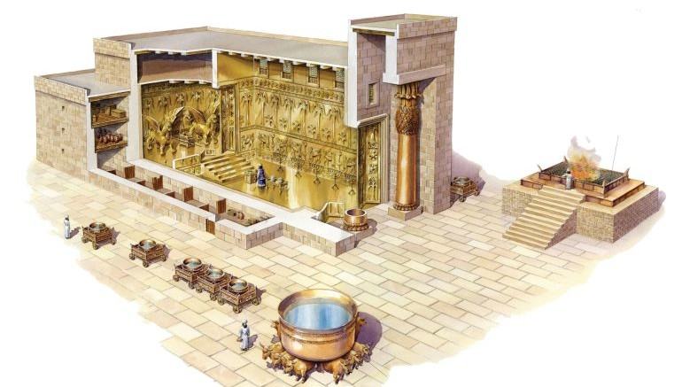
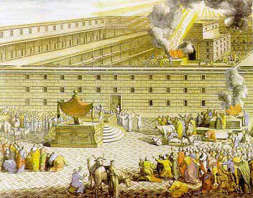
Read 1 Kings 6:7-38:
The temple was lined with carved cedar, and overlaid with gold. The carvings were gourds with flowers. In the holy of holies were carvings of palm trees, open flowers, and cherubim angels, covered with gold. There were also gold chains hanging. There were two 15’ high cherubim carved out of olive wood. Each had 15’ wing spans that touched each other in the middle of the room; and extended to the outer walls. The cherubim filled the holy of holies, which was 30’ x 30’ x 30’.
The temple took seven years to build.
Read 1 Kings 7:1-12 : Now Solomon built his own house. It was 150’ long, 75’ wide and 45’ high. It took 13 years to build.
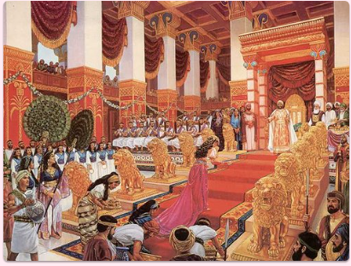
Read 1 Kings 7:13-39: Solomon brought in a world-class bronze artist who formed ornate capitals for the temple columns, and also made a large tub in front of the temple. It held 17,000 gallons. The big bath tub was for the priests to wash before each shift; and before putting on their priestly garments. In heaven there is a glassy sea before the throne.
All of this cunning artwork and detailed interior design was per Solomon’s vast imagination…and according to his Father’s wishes. Even so, anything that man touches gets smudged with our sinful nature. The Babylonians destroyed the temple when they sacked Jerusalem in 586 B.C. Ezra helped rebuild the temple a second time in 516 B.C.; but it was just a smaller and simple structure built at a time when Jerusalem was in ruins. Those who had seen the glory of the first temple cried in disappointment. This disturbed God; since men were more taken by the glory of men’s handiwork than having a place to commune with God.
Then he ^{[a]}said to me, “This is the word of the Lord to Zerubbabel saying, ‘Not by might nor by power, but by My Spirit,’ says the Lord of hosts. ⁷ ‘What are you, O great mountain? Before Zerubbabel you will become a plain; and he will bring forth the top stone with shouts of “Grace, grace to it!”’” ⁸ Also the word of the Lord came to me, saying, ⁹ “The hands of Zerubbabel have laid the foundation of this house, and his hands will finish it. Then you will know that the Lord of hosts has sent me to ^{[b]}you. ¹⁰ For who has despised the day of small things? ^{[c]}But these seven will be glad when they see the ^{[d]}plumb line in the hand of Zerubbabel—these are the eyes of the Lord which range to and fro throughout the earth.” (Zechariah 4:6-10)
Herod refurbished the second temple and did a massive renovation. God was not impressed with a faithless and sinful man’s building; and the Romans destroyed it in 70 A.D.
Jesus left the temple and was walking away when his disciples came up to him to call his attention to its buildings. ² “Do you see all these things?” he asked. “Truly I tell you, not one stone here will be left on another; every one will be thrown down.” (Matthew 24:2)
God sees construction materials differently than we do. We see the perfection of a cut stone to build a wall; but God prefers stones that no man has altered.
If you make an altar of stone for Me, you shall not build it of cut stones, for if you wield your tool on it, you will profane it. (Exodus 20:25)
God is more interested in the means and methods of our gift; than how impressive it is. Making shady deals to make money for greater tithing is a net gift reduction.
Read 1 Kings 7:40-51: The tabernacle was built from God’s blueprint. Solomon’s Temple was an amplification of that same plan. We want to impress God with more. God wants the quiet and simple time together. The tabernacle was not an attractive thing. It was to represent man (who is as dust). The temple was the most-impressive building on earth. That is not God’s point. The sacrificial system was a sin covering and a reminder that we are culpable for innocent blood. Solomon sacrificed thousands of animals in an effort to make God even happier. Again, he missed the whole point.

