Genesis 5
Read Genesis 5:1- 2: What does it mean that we were created in the likeness of God? Some say that is because God is a trinity (Father, Son and Hoy Spirit), and we are a trinity (body, soul and spirit). Others say that it is because only man has a spiritual component to discern right from wrong. Animals have no conscience; and are incapable of making a spiritual decision. God has made men to be governors over all living things.
We will be more like God when we are in heaven; because we will no longer have a sin nature and harmful desires; and we will no longer have this limited body of flesh.
See what great love the Father has lavished on us, that we should be called children of God! And that is what we are! The reason the world does not know us is that it did not know him. ² Dear friends, now we are children of God, and what we will be has not yet been made known. But we know that when Christ appears,^{[a]} we shall be like him, for we shall see him as he is. ³ All who have this hope in him purify themselves, just as he is pure. (1 John 3:1-3)
Our bodies are compared to a tent, that we live in. Tents wear out over time. We will have a heavenly body some day.
For we know that if the earthly tent we live in is destroyed, we have a building from God, an eternal house in heaven, not built by human hands. ² Meanwhile we groan, longing to be clothed instead with our heavenly dwelling, ³ because when we are clothed, we will not be found naked. ⁴ For while we are in this tent, we groan and are burdened, because we do not wish to be unclothed but to be clothed instead with our heavenly dwelling, so that what is mortal may be swallowed up by life. ⁵ Now the one who has made us for this very purpose is God, who has given us the Spirit as a deposit, guaranteeing what is to come. ⁶ Therefore we are always confident and know that as long as we are at home in the body we are away from the Lord. ⁷ For we live by faith, not by sight. ⁸ We are confident, I say, and would prefer to be away from the body and at home with the Lord. ⁹ So we make it our goal to please him, whether we are at home in the body or away from it. ¹⁰ For we must all appear before the judgment seat of Christ, so that each of us may receive what is due us for the things done while in the body, whether good or bad. (2 Corinthians 5:1-10)
Being made in God’s image partially means that we can relate to him, obey him and have a relationship with him.
We never become gods or equal to God in any way. There is only one God.
I am the Lord, and there is no other; apart from me there is no God. (Isaiah 45:5)
Revelation describes our eternal state as being able to more-fully appreciate God. God will share everything with us; and we will understand that we did not deserve it. He will make us mini kings and mini priests; but it won’t go to our heads.
the twenty-four elders fall down before him who sits on the throne and worship him who lives for ever and ever. They lay their crowns before the throne and say: ¹¹ “You are worthy, our Lord and God, to receive glory and honor and power,
for you created all things, and by your will they were created and have their being. (Revelation 4:10-11)
Born-again believers in Christ have two natures. One is ungodly and selfish. There is also another portion that is God’s Spirit deposited deep within us (like a homing beacon). Being more godly in nature is endeavoring to take on God’s mind and heart; by continuously and prayerfully putting his word in our minds. Knowing God is a process that we can never fully complete. We begin as a servant to our LORD. A servant is one who lives under a set of rules. God wants to get us well-beyond that legalistic and fearful relationship. He wants us to seek his presence more deeply; and know him as a friend. He wants us to use quality time to wait to hear from him. Our day should be an ongoing conversation with God. Abraham and Lot are examples of two men who exemplified how different the Christian life can be. Lot wanted his fire insurance; but he put himself and his family in harm’s way for the sake of financial opportunity. Abraham was on a journey to find the city where God lived. God shared his thoughts and plans with Abraham, his friend.
I no longer call you servants, because a servant does not know his master’s business. Instead, I have called you friends, for everything that I learned from my Father I have made known to you. (John 15:15)
God’s nature is seen in his character and attributes; more than by his appearance or form. Knowing God is like any relationship. We need to listen to him…we need to talk to him…and we need to do things together. We cannot say that we know God if we do not talk to him, listen to him or do things with him. In fact, we become quickly estranged from his fellowship as we go away from him.
We are not creators like God; but we desire to build things. God is far above all creation. Jesus is the creator of all things. This includes angels, demons, planets, molecules and cells. He is holding every single atom and every single solar system together; until they have served their purpose. Jesus was set apart far above all angels and demons by existing from everlasting to everlasting, and to be the creator of all things.
in these last days he has spoken to us by his Son, whom he appointed heir of all things, and through whom also he made the universe. ³ The Son is the radiance of God’s glory and the exact representation of his being, sustaining all things by his powerful word. After he had provided purification for sins, he sat down at the right hand of the Majesty in heaven. ⁴ So he became as much superior to the angels as the name he has inherited is superior to theirs. ⁵ For to which of the angels did God ever say, “You are my Son; today I have become your Father”^{[a]}? Or again, “I will be his Father, and he will be my Son”^{[b]}?⁶ And again, when God brings his firstborn into the world, he says, “Let all God’s angels worship him.”^{[c]7} In speaking of the angels he says, “He makes his angels spirits,and his servants flames of fire.”^{[d]8} But about the Son he says, “Your throne, O God, will last for ever and ever; a scepter of justice will be the scepter of your kingdom.
⁹ You have loved righteousness and hated wickedness; therefore God, your God, has set you above your companions by anointing you with the oil of joy.”^{[e]10} He also says, “In the beginning, Lord, you laid the foundations of the earth, and the heavens are the work of your hands. ¹¹ They will perish, but you remain; they will all wear out like a garment. ¹² You will roll them up like a robe; like a garment they will be changed. But you remain the same, and your years will never end.”^{[f]13} To which of the angels did God ever say, “Sit at my right hand until I make your enemies a footstool for your feet”^{[g]}? (Hebrews 1)
Becoming more selfless; and prioritizing the lives of others is a godly part of a person’s character. God’s sacrificial love and compassion are far greater attributes than any skill we may possess or value. To diminish our importance is counter intuitive to our fleshly nature.
That I may know him and the power of his resurrection, and may share his sufferings, becoming like him in his death (Philippians 3:10)
The natural and ungodly man is compared to the animal kingdom.
But these people blaspheme all that they do not understand, and they are destroyed by all that they, like unreasoning animals, understand instinctively. (Jude 1:10)
Read Genesis 5:3-32: There are now two distinct families on earth. The early men had many children; and the earth population grew very fast. Adam and Eve had another son named Seth to replace Abel. The line of Seth was the more-godly lineage that the messiah would come through. There were men of faith in this family. Enoch was a descendant of Seth. Enoch walked with God 365 years; and then God took him to heaven. Enoch is used as an example for us to walk with God 365 days per year. One day God will also take us home. When we walk with God as part of our daily existence; stepping into heaven is a natural transition. There is a salvation code found in the names from Adam through Seth:
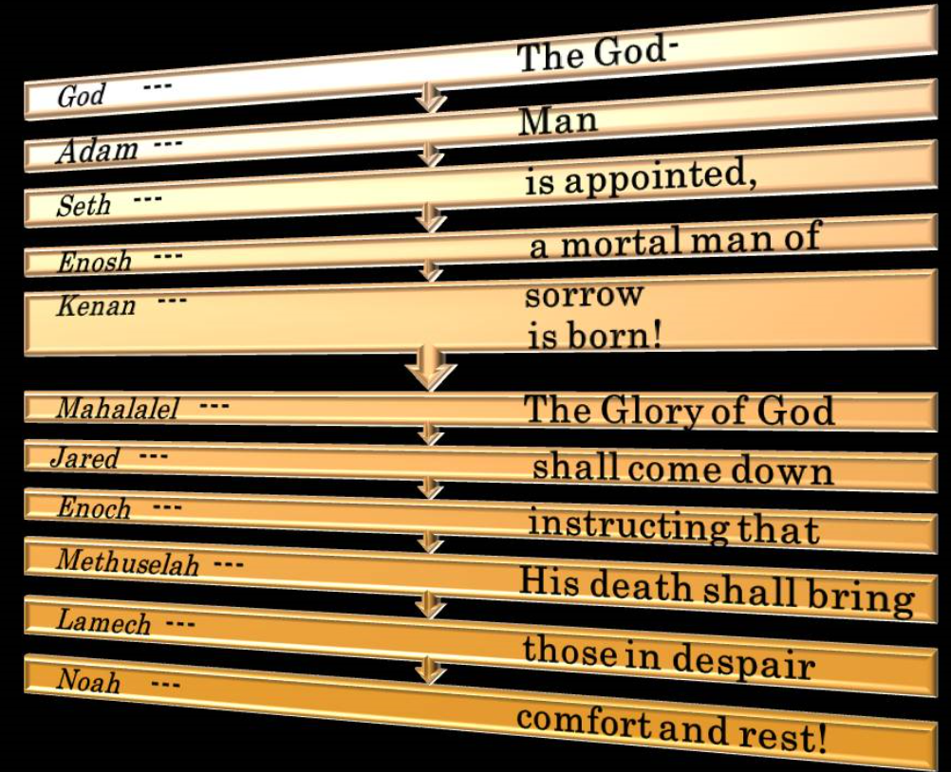
Methuselah was the oldest-recorded life span (969 years) for Good reason. Methuselah’s long lifetime fits with Peter's depiction of God's patience in 2 Peter 3. The flood did not come until he died. After discussing the Flood, the apostle Peter writes in verses 8-9:
But do not let this one fact escape your notice, beloved, that with the Lord one day is like a thousand years, and a thousand years like one day. The Lord is not slow about His promise, as some count slowness, but is patient toward you, not wishing for any to perish but for all to come to repentance.
Cain also had a family. They were known for polygamy, murder, anger, music, and as city dwellers. The family of Cain had become so corrupt that there was no longer any Godly influences. They had become dog eat dog and violent takers.
The family of Adam had some degree of separation from Cain’s family until we come to chapter 6. Once the wholesome family became one with the worldly family the concept of personal holiness completely disappeared. With one exception.
We are to live differently than the average Joe. We are to bring a different flavor into the world. We are supposed to be connected to truth and love and right living. Blending in with the world is not why we are here.
“You are the salt of the earth. But if the salt loses its saltiness, how can it be made salty again? It is no longer good for anything, except to be thrown out and trampled underfoot. ¹⁴ “You are the light of the world. A town built on a hill cannot be hidden. ¹⁵ Neither do people light a lamp and put it under a bowl. Instead they put it on its stand, and it gives light to everyone in the house. ¹⁶ In the same way, let your light shine before others, that they may see your good deeds and glorify your Father in heaven. (Matthew 5:13-16)
We will see soon that normal human behavior eventually becomes corrupt; unless God intervenes. We are to be blessings to those who know us; but we cannot become like our neighbors. God did not put us here to just go to work and raise families, like everyone else. We need to stand apart (with different objectives) as having something more important to accomplish here.
But you are a chosen generation, a royal priesthood, an holy nation, a peculiar people; that you should shew forth the praises of him who has called you out of darkness into his marvelous light; (1 Peter 2:9)

