Genesis 7
Read Genesis 7:1-5: This is a re-creation (so to speak). God made Adam and Eve and the huge diversity of creation. Now he has to erase it; because of sin. Any artist or builder hates investing their heart and soul into something that becomes worthless. God was patient with man. He did not bring destruction until the last man of faith was at risk. The world lives under the common grace extended to a single righteous soul. God tells Noah and his family to come inside to the safety and provision in the ark for protection from the coming destruction of all flesh. The shelter of the ark is compared to God pulling us into the safety of his presence (in heaven) when the great tribulation comes upon this world.
Go, my people, enter your rooms and shut the doors behind you; hide yourselves for a little while until his wrath has passed by. ²¹ See, the Lord is coming out of his dwelling to punish the people of the earth for their sins. The earth will disclose the blood shed on it; the earth will conceal its slain no longer. (Isaiah 26:20-21)
Noah was able to benefit from his own good works. He built a ship to save many people. He may not have known it would be filled with animals. Many times we try to rescue people; but end up making use of the intended assistance.
God told Noah to take 7 pairs of every clean animal; and one pair of every kind of unclean animal. The birds were also brought in pairs of 7. It was like going back to the original creation. Noah sacrificed some clean animals when he exited the ark.
Read Genesis 7:6-12: The flood started in the 600th year of Noah’s life, in the 17th day of the 2nd month. Most people don’t realize the whole flooding process lasted over a year.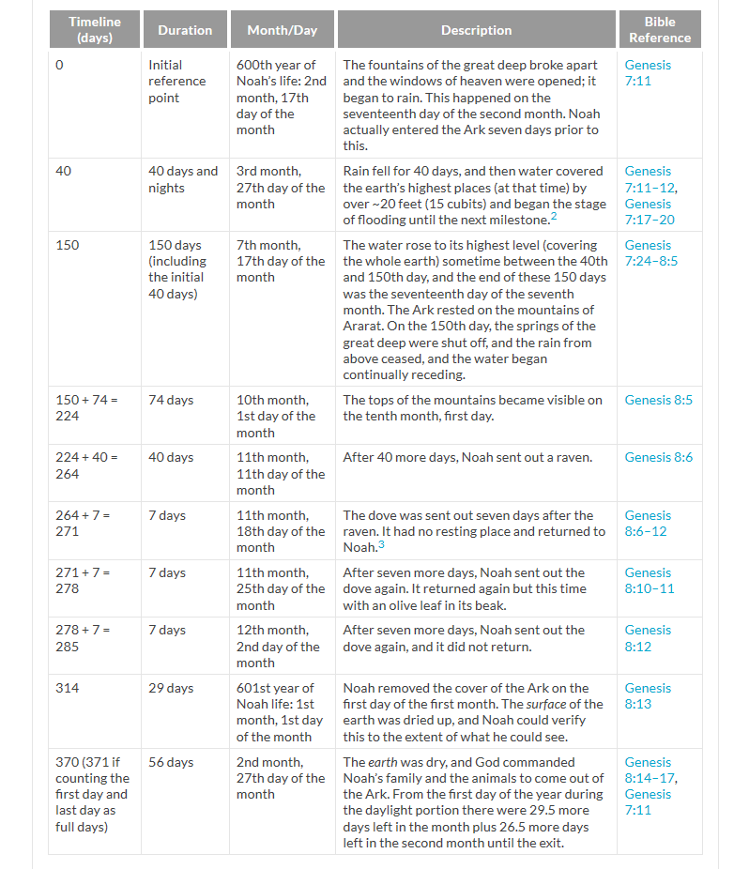
The springs of the great deep burst forth, and the floodgates of the heavens opened. How much water is below the ground? We have found groundwater at 5 miles below the earth’s surface.
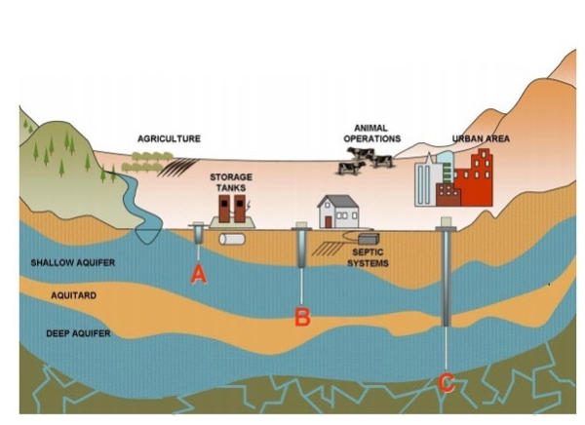
The difference between groundwater and deep subterranean water is pressure and mobility. The Russians drilled the world’s deepest hole (Kola Superdeep Borehole); which was abandoned at 7 miles deep. They encountered a lot of water the entire way.
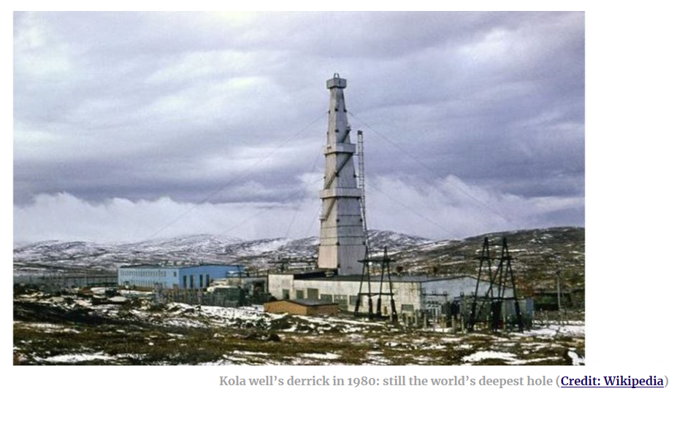
To be accessible groundwater there has to have cracks in rocks or have sand to be flowable. Groundwater is normally freely pumped from 200’ deep, on down to 2,000’ deep. During the recent drought in the San Joaquin Valley, farmers dropped wells from 200’ on down to 1,000’ in many cases. There are even some that got down to 3,500’. There is water everywhere; but you need to find flowing volume to have an economical well. The economics of drilling and pumping from deeper aquafers makes less sense. Water can also be found much deeper still, in a form called Ice VII. This is actually hot ice; that remains in a crystal form (much like a diamond) because the surrounding massive pressure.
There may not have been ay rain before Noah’s flood. Genesis describes a mist that came up from the soil. There was also a release of atmospheric water in the flood. One big storm cloud can hold a million tons of water. We need to remember that in the beginning of the creation of the earth; that the solution of water and mud was like a massive muddy pond. The soil settled out into continents. The earth re-dissolved into a muddy solution during the flood. Even Mount Everest (29,000’) was covered. That amount of water is even considerably more than current groundwater estimates. God stopped the flooding right after Mount Everest was covered with 22’ of water. That was all the water that was required. They have found fossils 3,500’ deep into the soil. The Grand Canyon allows us to see a cross section of flood settlement.
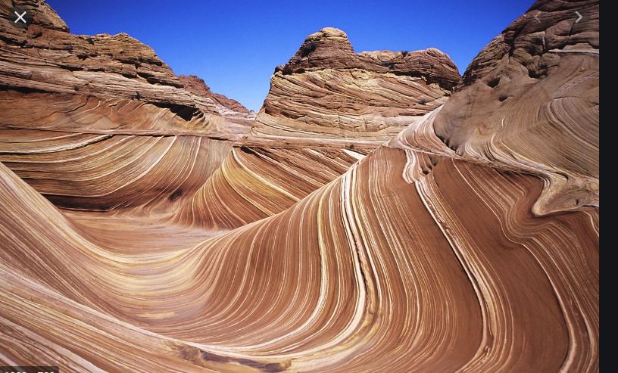
There are animals that walked on the ocean floor during the flood; and were encapsulated as things solidified and waves of sandy water covered the oceans. Furthermore, these tracks often show that the animals were moving in one direction while their feet were pointing in a different direction. It would appear that the animals were walking in a current of water, not air. Other trackways start or stop abruptly, with no sign that the animals’ missing tracks were covered by some disturbance such as shifting sediments. It appears that these animals simply swam away from the sediment. There is no other way that we could have whale skeletons on mountain peaks and deeply-buried skeletons.
Noah started his project at an old age. As Christians, we are never to retire from our service to God. Abraham really did not get started on his journey until he was 75 years old. Noah finished building the ark when he was 600 years old.
It rained for 40 days and nights. It began on the 17th day of the second month. I would not be surprised if the tribulation began at the same time of year. That appears to be around early May.
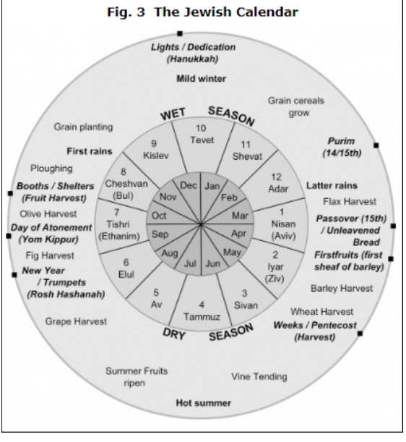
The pre-flood world was more like the equator is now. Antarctica currently has a 2-mile thick ice cap. Under that ice cap are bees, and plants and beavers and moles, etc…
Read Genesis 7:13-24: There is a lot of gravity to the idea that those who are lost will come to a place when they have run out of chances.
It is appointed for men to die once, but after this the judgment, (Hebrews 9:27)
We have a limited opportunity to share the gospel with those who are perishing.
How then shall they call on Him in whom they have not believed? And how shall they believe in Him of whom they have not heard? And how shall they hear without a preacher? ¹⁵ And how shall they preach unless they are sent? As it is written:“How beautiful are the feet of those who ^{[b]}preach the gospel of peace,
Who bring glad tidings of good things!” (Romans 10:14-15)

