Numbers 19
The Bible warned people to stay away from dead things long before we knew about germs and how disease spreads. There was a cleansing ritual for those who had defiled themselves. God continuously has steered his people away from things that bring death. God’s word brings life. God’s word is another name for Jesus. The idea is that it will dawn on the Bible reader that coming to Jesus with our whole heart is the fulfillment of the Law. In doing so; our intentions and actions will be softened and we will change into loving, law-abiding citizens.
Read Numbers 19:1-10: A red heifer without defect or blemish was to be located. A heifer is different than a cow; as she has not had a calf yet. Being without defect is to not have a genetic imperfection (including color). Being without blemish is to not have an injury or scar. The animal also had to also have never been used for work (pull a plow or wagon, etc..).
The heifer was to be killed outside of the camp. The priest was to take its blood on his finger, and sprinkle it 7 times towards the front of the tent of meeting.
The priest was then to observe the entire heifer being burned. The priest would add cedar wood, hyssop and scarlet wool; and throw them onto the fire. The priest would then wash his clothes and take a bath, and return. He would remain ceremonially unclean until sundown. The Levite who actually did the dirty work at the fire would also wash his clothes and bathe. He would also be unclean until sundown.
Afterwards a clean man would gather these ashes and store them in a clean place outside of the camp. They were a special resource to be kept for future cleansings, to purify from sin. The ash gatherer would likewise be unclean until evening.
There had to be people who had to bury their family members. Some exposure to death in this world is impossible. It was obviously a very expensive and time consuming hassle for the family and priest to go through this cleansing process. Whoever failed to cleanse themselves had to be killed.
Read Numbers 19:11-22: This ash collection was to be carefully inventoried. The people would need to be cleansed for various exposures. Bathing, quarantine and clothes washing were both a part of this ritual. Christianity is responsible for our modern medical hospital standards and germicides. The acts of bathing, changing clothes and quarantine for uncleanness were part of Christian requirements long before man knew about germs and contagious exposures. Christians were the first to build hospitals. Florence Nightingale and other people of faith transformed war zone and hospital patient care with astounding changes in survival statistics. Christianity and the Mosaic Law were responsible for solving the plagues tied to human sewage and trash accumulations. The Mosaic Law had enormous impacts on; leprosy, the black plague, bubonic plague and other serious plagues and worldwide death.
Of great significance is the fact that “purification” techniques involved also the rinsing or burning of the garment of the diseased person, shaving the hair of the head, beard, and even the eyebrows (Lev. 14:8–9) and sterilization by means of fire (Lev. 13:55–58). Thus, in effect, the ways to fight communicable diseases were to destroy the germs, or prevent their being carried to healthy people. This leads us to the conclusion that although germs which directly cause certain infections and diseases were obviously unknown in those days, there was an awareness of the notion that some diseases were caused by the entry into the body of some infective agents. ((Edward Neufeld, “Hygiene Conditions in Ancient Israel (Iron Age),” Journal of the History of Medicine and Allied Sciences 25 (1970); reprinted in The Biblical Archaeologist Reader IV, Edward Campbell and David Freedman, eds. (Sheffield, England: The Almond Press, 1983), 171.))
Touching a dead body, or enters a dead man’s tent would make you unclean for 7 days. There is a point behind the instruction. Christianity is about life, not death. We are living in a culture that increasingly celebrates things of death. As you drive down the highway you see bumper stickers for: The Greatful Dead, pirate skulls and crossbones, the Metal Mulisha skull and army helmet, etc..
“See, I have set before you today life and ^{[t]}prosperity, and death and ^{[u]}adversity; ¹⁶ in that I command you today to love the Lord your God, to walk in His ways and to keep His commandments and His statutes and His judgments, that you may live and multiply, and that the Lord your God may bless you in the land where you are entering to possess it. (Deuteronomy 30:15-16)

We need to understand that our life and health are ultimately about our fellowship with God. He is the giver of life. At best, an unbeliever will just robotically keep within the boundaries of the Law. It is like a fence around the playground. The Law is designed to perpetuate human existence in absence of faith. It is to keep us from straying too far away; and destroying ourselves. Acts of faith can seem to technically violate the letter of the Law…while keeping the Spirit of the Law. The Law holds us until we wake up to see God’s goodness behind it all. Israel has been blind to the purpose of the Law. They got stuck thinking that the Law was the ultimate thing. They missed the point.
You search the Scriptures because you think that in them you have eternal life; it is these that testify about Me; (John 5:39)
“Because this people draw near with their ^{[p]}words And honor Me with their ^{[q]}lip service, But they remove their hearts far from Me, And their ^{[r]}reverence for Me ^{[s]}consists of ^{[t]}tradition learned by rote, ¹⁴ Therefore behold, I will once again deal marvelously with this people, wondrously marvelous; And the wisdom of their wise men will perish, And the discernment of their discerning men will be concealed.” (Isaiah 29:13-14)
Jesus purposely put himself in situations where he technically did not keep the Law in some small aspect…but he kept the purpose of it. The Pharisees were used by God to contrast saving faith and robotic legalism.
Think about how the Apostle John and Peter knew that meeting Jesus after his crucifixion was more important than becoming ceremonially unclean. John was influenced by the Law of being ceremonially-unclean more than Peter. It did give them a cause to pause before entering the grave. Being close to Jesus is what the Law is ultimately all about.
So Peter and the other disciple went forth, and they were going to the tomb. ⁴ The two were running together; and the other disciple ran ahead faster than Peter and came to the tomb first; ⁵ and stooping and looking in, he *saw the linen wrappings lying there; but he did not go in. ⁶ And so Simon Peter also *came, following him, and entered the tomb; and he *saw the linen wrappings lying there, ⁷ and the face-cloth which had been on His head, not lying with the linen wrappings, but rolled up in a place by itself. ⁸ So the other disciple who had first come to the tomb then also entered, and he saw and believed. ⁹ For as yet they did not understand the Scripture, that He must rise again from the dead. ¹⁰ So the disciples went away again to their own homes.(John 20:3-9)
Technically both men ceremonially contaminated themselves and their families when they went home after being in Jesus’ tomb. They both new that being with Jesus was more important than any technicalities. Jesus is the fulfillment of the Law; not the end of the Law.
“Do not think that I came to abolish the Law or the Prophets; I did not come to abolish but to fulfill. ¹⁸ For truly I say to you, until heaven and earth pass away, not ^{[h]}the smallest letter or stroke shall pass from the Law until all is accomplished. ¹⁹ Whoever then annuls one of the least of these commandments, and teaches ^{[i]}others to do the same, shall be called least in the kingdom of heaven; but whoever ^{[j]}keeps and teaches them, he shall be called great in the kingdom of heaven. ²⁰ “For I say to you that unless your righteousness surpasses that of the scribes and Pharisees, you will not enter the kingdom of heaven. (Mattthew 5:17-20)
The Pharisees kept the Law in a ridiculous way. They went way beyond the mere face value of it. They made mountains out of molehills. Unfortunately, they also circumvented the underlying purpose of the Law for personal interests. The books of Moses (Genesis-Deuteronomy) are referred to as the Law, or the school master, teacher or the guardian. It was written for unbelievers. The unbelievers are referred to as slaves to sin or those being tutored like a child…until they can think properly for themselves. You cannot fulfill the Law perfectly; so you become subject to its punishments. It becomes a hard warden. There is no way to fulfill it or beat it on your own. It is supposed to bring you to the conclusion that we need God’s help, and throw ourselves on the mercy of the court.
But we know that the Law is good, if one uses it lawfully, ⁹ realizing the fact that law is not made for a righteous person, but for those who are lawless and rebellious, for the ungodly and sinners, for the unholy and profane, for those who kill their fathers or mothers, for murderers ^{10 [f]}and ^{[g]}immoral men ^{[h]}and homosexuals ^{[i]}and kidnappers ^{[j]}and liars ^{[k]}and perjurers, and whatever else is contrary to sound teaching, (1 Timothy 1:8-11)
The 10 Commandments teach us about right and wrong. The goal is that we will wake up and see that we need to be born again, and receive Jesus as our personal Lord and savior. Until that time, the writings of Moses is like a catechism.
Now I say, as long as the heir is a ^{[a]}child, he does not differ at all from a slave although he is ^{[b]}owner of everything, ² but he is under guardians and ^{[c]}managers until the date set by the father. ³ So also we, while we were children, were held in bondage under the ^{[d]}elemental things of the world. ⁴ But when the fullness of the time came, God sent forth His Son, born of a woman, born under ^{[e]}the Law, ⁵ so that He might redeem those who were under ^{[f]}the Law, that we might receive the adoption as sons. ⁶ Because you are sons, God has sent forth the Spirit of His Son into our hearts, crying, “Abba! Father!” ⁷ Therefore you are no longer a slave, but a son; and if a son, then an heir ^{[g]}through God. (Galatians 4:1-7)
Today; there are some Jews who still follow the Law. They plan on rebuilding a temple. To do so, they say they need the ashes of a red heifer to cleanse it and dedicate it. A red heifer that met the perfection requirements was recently born. It had been anticipated by the Temple Institute as a necessity to rebuild the modern temple. It would be needed to be cleansed to dedicate it into service.
https://www.youtube.com/watch?v=byAoFbA6cr8
The link above has an interview with a Rabbi regarding the recent arrival of the long-awaited perfect red heifer.
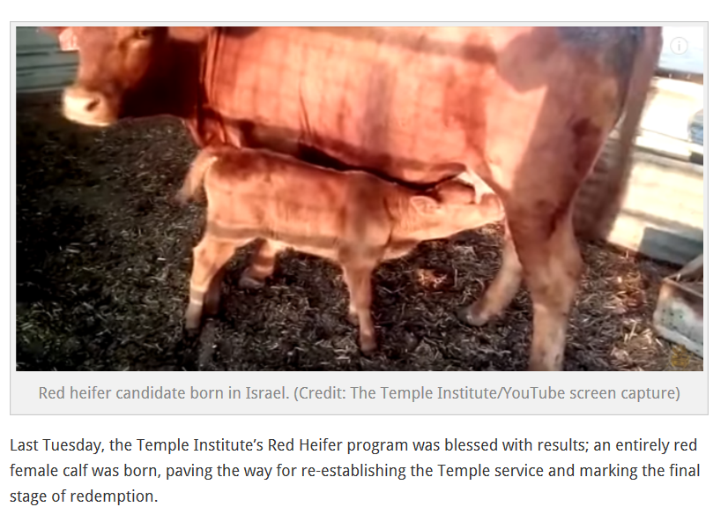
What about the cedar, hyssop and scarlet wool materials that are to be tossed into the red heifer sacrificial fire? These items were similar to other Biblical cleansing rituals. The cleansing of leprosy was similar.
Then the Lord spoke to Moses, saying, ² “This shall be the law of the leper in the day of his cleansing. Now he shall be brought to the priest, ³ and the priest shall go out to the outside of the camp. Thus the priest shall look, and if the ^{[a]}infection of leprosy has been healed in the leper, ⁴ then the priest shall give orders to take two live clean birds and cedar wood and a ^{[b]}scarlet string and hyssop for the one who is to be cleansed. ⁵ The priest shall also give orders to slay the one bird in an earthenware vessel over ^{[c]}running water. ⁶ As for the live bird, he shall take it together with the cedar wood and the ^{[d]}scarlet string and the hyssop, and shall dip them and the live bird in the blood of the bird that was slain over the ^{[e]}running water. ⁷ He shall then sprinkle seven times the one who is to be cleansed from the leprosy and shall pronounce him clean, and shall let the live bird go free over the open field. ⁸ The one to be cleansed shall then wash his clothes and shave off all his hair and bathe in water and be clean. Now afterward, he may enter the camp, but he shall stay outside his tent for seven days. ⁹ It will be on the seventh day that he shall shave off all his hair: he shall shave his head and his beard and his eyebrows, even all his hair. He shall then wash his clothes and bathe his ^{[f]}body in water and be clean. (Leviticus 14:1-9)
The word scarlet comes from the blood of a worm that commits suicide to complete the life cycle, and provide life to its offspring. Tola is the Hebrew word for red. It is actually scarlet. This word is derived from the worm/maggot coccus ilcis. Its blood is a special dye referred to in the Bible. Jesus called himself a worm of this kind. He was born to die for others to have life.
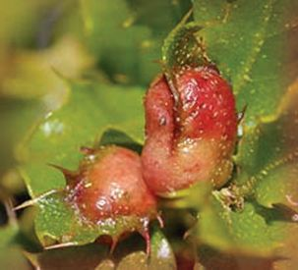

The coccus ilicis female lays eggs on the bark of a tree and attaches herself over the eggs as protection. As the larvae consume her body, her blood runs down the tree, staining it. If the worm was harvested at the right time, the blood could be used to dye fabric. The fabric for the Tabernacle and the priests' robes were presumably dyed this way, but the word for "scarlet" is also used in passages like Psalm 22:6 ("But I am a worm, and no man...") The dye was commonly used in ceremonial items, most likely referencing blood. But it also brings to mind sin, which, like blood, draws attention to itself in a cry for healing.
Hyssop and the cedar tree are examples of the greatest to the least of the plant kingdom. The hyssop was 12”-24” tall.
He spoke of trees, from the cedar that is in Lebanon even to the hyssop that grows on the wall (1 Kings 4:33)
The hyssop was known for its medicinal uses. The cedar’s wood was used to prevent mold and pest infestation.
Purify me with hyssop, and I shall be clean; ^{[h]}Wash me, and I shall be whiter than snow. (Psalm 51:7)

