Psalm 44
The Bible is a compilation of history and experiences written down and passed onto future generations. Do we revere what has been carefully recorded and passed down to us? The devil is a revisionist. History gets re-written, lost and forgotten over time. All of the Bibles were supposedly all purposefully destroyed numerous times. That is proof of it’s unparalleled value. Yet God kept enough copies safe. We need to be committed to truth; even when it works against us.
For whatever things were written before were written for our learning, that we through the [c]patience and comfort of the Scriptures might have hope. (Romans 15:4)
Read Psalm 44:1-3: The sons of Korah were reflecting on the accounts relating to Joshua, and the return of the children of Israel to the land of Canaan. God made it pretty obvious that despite Joshua’s obedience; his military success was supernatural. God wants us to try our hardest; but ultimately it is God who prevails. The supernatural can have natural accompaniment or not.
For starters, how did the Jordan stop flowing? It could have been supernatural or natural. It may have been God using nature. We now know how the Jordan River gets periodically dammed up. The crossing of the Jordan could have been made possible by a mudslide, itself caused by an earthquake precisely where the book of Joshua specifies. Historical records confirm that such mudslides that temporarily dam up the river have occurred from time to time at that very location on the Jordan, including in the years 1160, 1267, 1546, 1834, 1906, and 1927.
What do we know about Jericho’s walls falling down? It was a case of God using the supernatural. There is evidence that the walls of Jericho did not fall inward. They fell outward! In reality what Kenyon, Garstang and other excavators have found at Jericho correlates precisely with the account in the book of Joshua. They found collapsed walls, not walls that were broken down from the outside but that had fallen down (Jos 6:20). The walls had not fallen inward, but outward, creating a ramp of fallen bricks by which the Israelites "went up into the city, every man straight before him" (Jos 6:20).
In chapter ten of the Book of Joshua, the Israelites go to war against five kings in order to help the Gibeonites, with whom they had signed a pact. While Israel was prevailing in the battle, God sent down stones from heaven to smite the enemy. God may have used the natural or supernatural here. Joshua prayed for the sun to stand still in order to have time to complete the victory. God answered his prayer. And the sun stood still, and the moon stayed, until the nation had avenged themselves of their enemies. Is not this written in the book of Jashar? And the sun stayed in the midst of heaven, and hasted not to go down about a whole day. Joshua 10:13
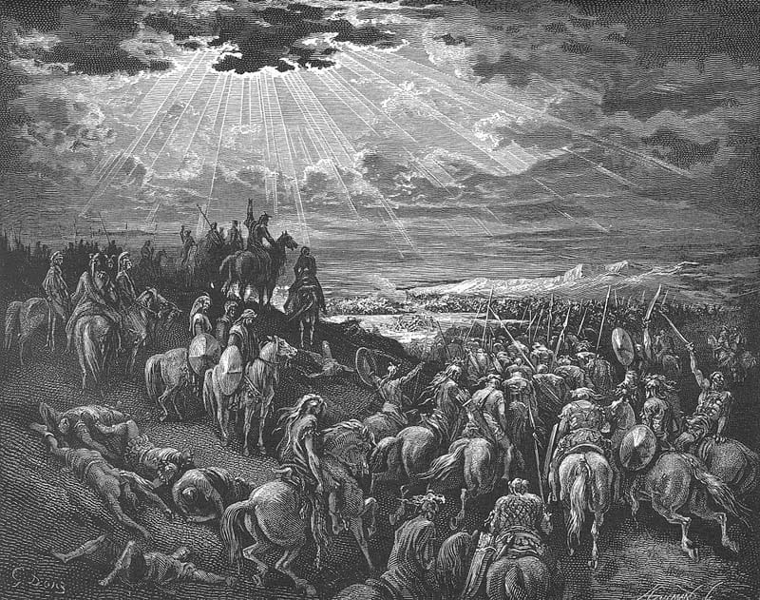
Joshua commands the sun to stand still (Wikimedia)
Using data from NASA tracking astronomical events, the team of scientists ascertained that the only solar eclipse which occurred during the period when the Jews are believed to have entered Israel was on October 30, 1207 BCE. Though the Bible mentions other cases of the sun standing still, the story in the Book of Joshua is unique in that it also mentions the role the moon plays in the process. This led the scientists to conclude that the Bible was relating a case of a solar eclipse, in which the moon comes between the earth and the sun.
One glaring difficulty for the scientists’ theory is that the Bible describes the sun lingering in the sky for an extended period of time. Their explanation, a solar eclipse, is precisely the opposite: the sun disappearing at a time it normally appears in the sky. The scientists resolve this contradiction using Hebrew etymology. The description of the event in the Book of Joshua uses the word דֹּם (dom), usually understood as ‘stand still’. The word is only used in one other place in the Bible. The scientists concluded that the word דֹּם (dom) actually means ‘to become dark’. Though this explanation may seem unlikely at first glance, the report cited several classical Jewish sources which state the event described in the Book of Joshua was actually a solar eclipse.
It makes no difference if the LORD uses periodically-possible occurrences...or if he just does a one-time miracle. We have a capacity to get used to daily miracles and call them natural. We dismiss how everything works out perfectly for us. How is it that our economy has not collapsed? How is it that we have copies of the Bible and living Jews as the most-hunted and destroyed things on earth?
It is the glory of God to conceal a matter (Proverbs 25:2)
Either way, Joshua’s final score was 31 kings defeated in 13 battles over 7 years (plus the Amalekites, Og King of Bashaan, and Sihon King of Sihon). It was similar to the accounts of the 40 years in the wilderness and the crossing of the Red Sea...or if you like: the 7-day creation account, etc… The Bible is a book of supernatural occurrences. You have to get past Genesis 1:1 to go any further.
Read Psalm 44:4-8: Unbelievers tend to fall to their weaknesses; and believers tend to fall to their strengths. I pray less over the things that I feel the most confident about. It is really no different than God using nature versus the miraculous. Using our God-given talent or opportunities still requires prayer. I have seen that we can have the talent, opportunity, timing, and confidence...and still fall flat on our face. At other times; I have been in unsure situations with doubtful outcomes. Praying in advance over my concerns seems to create a supernatural confluence of unlikely events to become a success. The question can become: Would you rather be good or blessed? The young man would want to be good (deep down). He wants to be worthy and accomplish something. The older man realizes that the outcome is more important. He is less hung up about failing forward; and letting God auto-correct my mistakes. The psalmist realizes that his sword is only the method of God’s choice. We are required to put forth the effort and planning. I can’t tell you how many times that I will be making an effort out of obedience; and considering it to be unfruitful. Then someone comes into the picture and handles it for me.
Read Psalm 44:9-16: These blessings listed previously are unending. Likewise; God will spare nothing to turn us back from going the wrong direction. The children of Israel walked away from God; and they lived like the rest of the world.
“Therefore say to the house of Israel, ‘Thus says the Lord God: “Repent, turn away from your idols, and turn your faces away from all your abominations. 7 For anyone of the house of Israel, or of the strangers who dwell in Israel, who separates himself from Me and sets up his idols in his heart and puts before him what causes him to stumble into iniquity, then comes to a prophet to inquire of him concerning Me, I the Lord will answer him by Myself. 8 I will set My face against that man and make him a sign and a proverb, and I will cut him off from the midst of My people. Then you shall know that I am the Lord. (Ezekiel 14:6-8)
God did not sell out his people to the Assyrians or Babylonians. They left him after repeated urgings to repent. In fact, the whole Babylonian invasion was Habakkuk’s answered prayer. His own people became intolerable and dangerous to themselves.
Read Psalm 44:17-22: This is a much quoted psalm. It is applied to martyrdom and bearing our own cross. It seems to be either a contradiction or a switch back and forth between good times and bad times. It is written to a mixed multitude. Like parables; there is a different message in it for everybody. They are all true at the same time. It is all about faith development. God loves his people; and he will let someone spank them as required. How do we who are obedient fare while our nation gets spanked? See it for what it is. See the purpose of your existence for what it is. It is not a retirement plan; it is a work plan. Have you started? They more we try to run from his calling (like Jonah) the more our relaxation gets disturbed. If you want to be at peace; do what God told you to first...then rest.
Read Psalm 44:23-26: The closer our face gets to the dirt, the louder our prayers become. What else should God do to a society that refuses to repent? What about us being stuck on faith plateau # 56? How can God move us on to level 57? With sharp sticks if necessary; like a mother eagle. She makes the high nest unbearable; until her little ones venture out. Are you tired of being tired? Take your next step towards God; and experience his refreshing positive reinforcement to your soul. If we are described as sojourners; that means travelers...not those who stay put in our ways.

