Amos 6
Read Amos 6:1-8: It is easy to read the Bible in a way that makes the sins of the ancient civilizations seem foreign to us. It seems like villains such as Jezebel and the Assyrians are almost inhuman; and un-relatable. It also makes the heroes like Moses, David and Elijah to be larger than life. The scriptures are written by God’s Spirit through inspired men’s hands. It is all written for our learning; but some of it does not seem to fit any of our life applications. We cannot lose track of the difference between how God sees things; and how we usually see things.
Let’s re-state the events of this chapter into the language and setting of our daily lives. What is it that brings us peace and a sense of well-being? For most people in America, it is having a reliable source of income and savings, and good health. Most residents in neighborhoods across America take rest in their family relationships, comforts of home, and our entertainment. For most Americans, God is not the highest priority in this equation. We cannot read the scriptures in a way that makes the fallen societies of the past seem ludicrous and beyond the scope of our sensibilities. Mankind does not change. Let’s re-read this chapter, based on the way it looks through modern man’s eyes:
The northern 10 tribes were living the life, prior to the invasions of Assyria. They had solid military and economic alliances with the surrounding nations. The Philistines had a solid military to provide a security buffer to the west. The Philistines were at hand for any war-time assistance. The Assyrians were also strong country. They provided a security buffer to the east. Initially, there was an alliance between Israel and Assyria. There were also Israeli castle-like fortresses to provide areas of refuge for national emergencies. The Israelis were well-healed; and partaking of the finer things in life. Israel was prosperous; and well positioned. Their cousins to the south in Judah were looked down upon; as being insignificant. Israel’s residents were not knocking themselves out to make a living. They had plenty of impoverished farm workers who would do the heavy lifting. This allowed the land owners continue to further leverage their successes; and add to the size of their enterprises.
Woe to you who add house to house and join field to field till no space is left and you live alone in the land.⁹ The Lord Almighty has declared in my hearing:“Surely the great houses will become desolate, the fine mansions left without occupants. (Isaiah 5:8-9)

This favorable economic environment allowed for leisure pursuits. There was plenty of time for socializing, developing hobbies (like golf), partaking of wine tastings, attending concerts, upgrading exquisitely-decorated high-end homes, and seeking out the finest foods and clothing. You could compare their lives to some of those living in Rancho Santa Fe. They were insulated from the normal daily struggles. People who are well-healed may desire to be in touch with reality; but there is no substitute for necessity. You can’t instill moral values and work ethics in your family apart from personal involvement.
The Israelis also lived a progressive lifestyle; and felt free to step outside the confines of traditional marriage. The Mosaic Law served a purpose for their great grandfathers, but their situation had changed. They did not deny themselves of any pleasure. This is a picture of men obtaining what they wanted…and then to venture into more exotic lifestyles…as those adventures became boring. This might have some appeal to mankind; but it is not what God wants for us. We all try to live more-comfortable lives. People may have even worked hard to get to a place of rest and prosperity.
Every way of a man is right in his own eyes, But the Lord weighs the hearts. (Proverbs 21:2)
We tend to give ourselves the nod as it pertains to our past times and pleasures. You really have to experience a major setback to re-evaluate your lifestyle. It can seem to be fun for a season. They were fat and blind and in denial of what lied ahead.
“For my thoughts are not your thoughts, neither are your ways my ways,”
declares the Lord. “As the heavens are higher than the earth, so are my ways higher than your ways and my thoughts than your thoughts. (Isaiah 55:8-9)
Samaria and Judah are described as two sisters, who were bad girls. They were well taken care of; but they got into trouble when they had free time and success. They did not discriminate who they got mixed up with. They made poor selections for friendships. They became like the surrounding, godless nations. God told them to be holy; and stay away from the local idolaters.
When the Lord your God brings you into the land you are entering to possess and drives out before you many nations—the Hittites, Girgashites, Amorites, Canaanites, Perizzites, Hivites and Jebusites, seven nations larger and stronger than you— ² and when the Lord your God has delivered them over to you and you have defeated them, then you must destroy them totally.^{[a]} Make no treaty with them, and show them no mercy. ³ Do not intermarry with them. Do not give your daughters to their sons or take their daughters for your sons, ⁴ for they will turn your children away from following me to serve other gods, and the Lord’s anger will burn against you and will quickly destroy you. ⁵ This is what you are to do to them: Break down their altars, smash their sacred stones, cut down their Asherah poles^{[b]} and burn their idols in the fire. ⁶ For you are a people holy to the Lord your God. The Lord your God has chosen you out of all the peoples on the face of the earth to be his people, his treasured possession. (Deuteronomy 7:1-6)
Christianity is a celebration of life. We live in a culture that flirts with debauchery and death. If you do not have a healthy fear of the LORD; you may allow yourself to listen to trashy musical lyrics. You might give into watch the worst TV shows and movies. Sooner or later the moral codes of your grandparents seem to be non-factors in you thinking. Once you enter into the strange life; and break bonds with a healthy family lifestyle, you start to spin out of control. Eventually they broke loose of every social mooring. Like a prostitute, they would entertain any offer.
“‘But you trusted in your beauty and used your fame to become a prostitute. You lavished your favors on anyone who passed by and your beauty became his. ¹⁶ You took some of your garments to make gaudy high places, where you carried on your prostitution. You went to him, and he possessed your beauty.^{[b]} ¹⁷ You also took the fine jewelry I gave you, the jewelry made of my gold and silver, and you made for yourself male idols and engaged in prostitution with them. ¹⁸ And you took your embroidered clothes to put on them, and you offered my oil and incense before them. ¹⁹ Also the food I provided for you—the flour, olive oil and honey I gave you to eat—you offered as fragrant incense before them. That is what happened, declares the Sovereign Lord. (Ezekiel 16)
Read Amos 6:9- 14: The mind that has become alienated to God does not process logic correctly. As we run from the truth, the truth escapes us. God can give us a chance to repent before the storm. This is an appeal to intellectual honesty and impartial assessment. Desire cannot skew our view of ourselves. Some people refuse to take direction for their lives. Even greater consequences can come as people refuse to repent. Those who do not repent after a catastrophe become afraid of God; and develop a hatred for him.
Here we read about the aftermath of a personal judgement. Someone comes to remove a corpse from a home. Normally this is an opportunity to console the survivors; and reference scripture. Instead, they are told to not even mention God. Unbelievers do not want to invoke God’s name. They think the answer is to plug their ears and eyes. Covering the truth, or suppressing reality only produces an imaginary situation.
Common sense is tied to the fear of the LORD. Today, we have many intelligent people; who make the worst decisions (when it comes to anything moral). A mind in rebellion refuses to acknowledge God. Anything that even points to anything godly is banned along with it. Expressions of faith go from being unfashionable to becoming banned. We hear it today: “Take the 10 Commandments off of the courthouse...take prayer out of the schools…remove the war memorial crosses…etc..
Wishful thinking has replaced reality. We hear it on the news every night. People will reject solid advice; because it would give validity to their opponent. These verses provide examples of pretentious thinking. Horses do not run on rocks like a mountain goat. Oxen do not plow in solid rock. Neither is equipped for it. Wanting to do something does not bring it to pass. The people had created a life that Moses had told them they could not have. Burning Bibles does not change God’s mind. This all reveals who Satan blinds us with our passions. Our lusts are compared to being drunk.
Amos 7
Read verses 1-9: God sent a plague of untimely locust swarms to slow down the sinners in Israel. Amos intervened; and the plague was lifted. God sent another plague of fire. Amos intervened for the people again; and God lifted that plague.
We need to pray to spare those who are lost in sin. We need to reach out to those who are at risk of judgement. At some point however, we also need to pray that God will heal our land. It is like intervening for an alcoholic who keeps reverting to old ways. At some point you need to step back and let God give them a dose of reality. To do so; often requires the destruction of evil. God used locusts to wipe out food sources. The prophet would intervene to stabilize the situation. God would send a cleansing fire to bring down the filthy establishments. The prophet would intervene, to save the city from complete destruction. Plagues and penalties for sin are like the Law of Moses. They don’t save many people. They just stem the rebellion for a while. At some point the people become so deluded and brazen that they have to either be eliminated or be brought to a place of severity to stop it. God was reminding the people that they had come up to a hard stop. If they went downhill any further they would be killed or removed. God was intervening with push back and pain bumpers, to prevent the society from passing over the line.
Those who fallow foolish pursuits lose track of the difference between right and wrong. We get lost in our imagination. We need to re-set our moral compass. At some point God shows us what righteousness is. A plumb line is a perfectly vertical standard of comparison. Righteousness is anything that points straight up to heaven. The walls and lives of the unrighteous are not very vertical. A wall can only hold up if it is built righteously-plumb. Their society was falling and tilted; and not structurally-sound. Any skewed wall has to be brought down for public safety. It will lean more as time goes on; and eventually crush the innocent. In the same way; we have to pray that God clean up our messes; realizing that lives will be lost in the demo process. These tilted walls need to be completely demolished. They cannot just be built up. We can blow the horn before the demolition detonates; but some will refuse move out of harm’s way. As Christians amidst mini-plagues, we need to flourish, minister and stand clear.
The shelter-in-place has been like a small Sabbath-rest for us. The Jews had laws about taking regular time off to rest and worship. We tell ourselves that we can ignore these rules as needs require. In reality, it damages us emotionally and physically. God would bring about circumstances that forced them to stop. God desires that no man would perish; but he is committed to clean up our messes; that life may continue. Thank you Good Father. God has pushed me off of my tracks; when I was wrapped up in an endless workday pattern. As conditions worsen, making life intollerable you change your thinking. These mini-plagues are like bumps on the highway that let you know that you are dangerously veering off of the road. You become more open-minded to having God take drastic measures to get life back in order. God normally has to take the joy out of the situation; for us to yield. God has begun to lessen the effects of Covid worldwide, as we pray for deliverance. Like Amos; we have called out to God for relief; and God is acting.
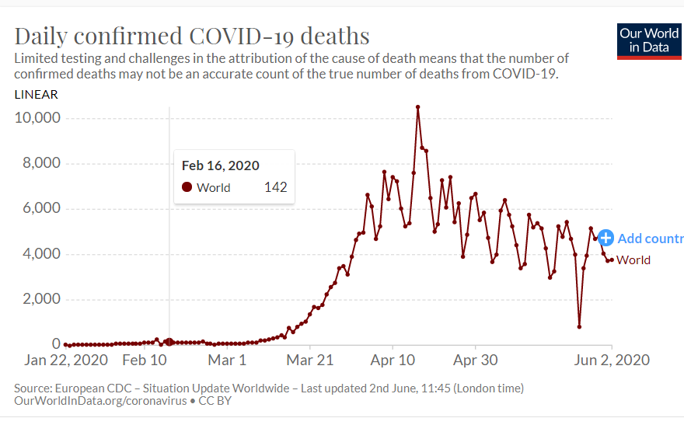
Like Amos; we see one plague on the decline as another gets underway. We are now experiencing rioting in the streets and anarchy on the heels of the decline of Covid. Our people are entertaining the idea of reducing their police forces. Our thinking is illogical and wishful, and misguided. What does this mean for us? It probably means the same thing as it did to Amos and his people. We are close to becoming unsustainable; and hopelessly divided. God is putting bumpers in our path; and he is pushing us back away from the cliff. We too are repeatedly striving towards self-destruction. We really need a mighty work of the Holy Spirit.
Read Amos 7:10-13: The healthy response to a doctor’s prognosis is to take the treatments. Unfortunately, Amaziah, the King of Israel went a different direction. He blamed the current state of affairs on the prophet! It was as ridiculous as Ahab blaming Elijah for proclaiming the drought. That is exactly like blaming Trump for racism, Covid, or anything else that does not correlate.
…The word of the Lord came to Elijah: “Go and present yourself to Ahab, and I will send rain on the land.” ² So Elijah went to present himself to Ahab….Ahab went to meet Elijah. ¹⁷ When he saw Elijah, he said to him, “Is that you, you troubler of Israel?” ¹⁸ “I have not made trouble for Israel,” Elijah replied. “But you and your father’s family have. You have abandoned the Lord’s commands and have followed the Baals. (1 Kings 18)
Our President, and others before him get criticized for upholding some moral standards. In the same way, we will not be able to win our neighbors over with logic. The time has come for us to doers of God’s word; who win people over with our daily lives, walking in the Holy Spirit.
…encourage the young men to be self-controlled. ⁷ In everything set them an example by doing what is good. In your teaching show integrity, seriousness ⁸ and soundness of speech that cannot be condemned, so that those who oppose you may be ashamed because they have nothing bad to say about us. (Titus 2:6-8)
Read Amos 7:14-17: It is difficult to speak God’s words and not be effected by how your message is received. It is normal to experience frustration when the word of God is rejected. We can also feel gifted when it is effective. Both views are a little off target. It is really a work of the Holy Spirit. Amos distances himself from the content of the prophetic message. We are letter carriers. We need to let people know that their argument is with God; not us. We are just sinful messengers.
Amos responds to the outcry against him; as if he has anything to do with the plagues. Amos shares that he was minding his own business and working in the fields. God called him out of his involvements; to prophesy. Prophecy is normally not all pleasurable; or an extension of our thinking. It is a heavy burden:
The burden of the word of the Lord to Israel by Malachi. (Malachi 1:1)
Silencing believers is like unplugging a fire alarm. That noisy and unpleasant sound of pending danger needs a response…not to be unplugged. Now the King is telling Amos not to prophesy anymore. The King and the people have now been properly served. Amos tells the King that the plagues will ruin the country and his family. His family will break up and be killed or become subjected to despicable means of survival. His country will be demolished; and wiped clean. It is actually not even the King’s property. God will not let his property become further polluted. What is needed in America is to have the Holy Spirit transform our land before it is destroyed. We think that we have unlimited self-determination over our lives. In the same way; our national set backs are coming in more rapid-fire succession. All of these self-destructive and outside plagues are telling us something. In reality; we can only make right and wrong reactions to God’s course corrections. Everything that follows are the uncontrollable consequences. Respond to God by making him a bigger part of your daily joy and purpose. Help heal our land.

