Numbers 15
Most of our information and details about sacrifices are found in the book of Leviticus. Most of the sacrifices are to cover the sins of men. The book of Numbers is about the wilderness journey. There was to be a change in the way that sacrifices were given when the people left the desert, and entered into the holy land. The entry into the holy land was still a distant-future event. God added a grain offering and wine offering to accompany other sacrifices. Grin offerings and drink offerings were not to be offered in the desert. God was still planning on letting his people enter this new land in approximately 40 years.
The wilderness experience was to keep the unbelievers from destroying themselves. The life in the land of Canaan (abundant life) was for believers to learn to walk with God in fellowship and spiritual growth.
We may also find our own lives just endlessly going in circles; and filled with disappointment. We may find ourselves conforming to Christian patterns; but still missing a deep satisfaction and peace.
Read Numbers 15:1-13: God told Moses to modify their sacrifices when they do enter the land of Canaan. It seems strange to be having this conversation 37 years before it happens. In addition, Moses would never be allowed to enter the land of Canaan. That proves that this whole life experience was largely documented for the benefit for following generations. All of the mistakes of Adam and Eve and the mistakes of the children of Israel worked perfectly to form our modern operating manual (the Bible). People have not changed over time.
The sacrificial supplement would become a grain offering (meal offering) and a drink (wine) offering. The children of Israel could not offer these as long as they lived in the desert. There was no grain or wine there. The manna could not have been offered as a sacrifice because they did not produce it…so there would have been no sacrifice factor to it.
The prescriptive requirements of all sacrifices were not common household inventory. The animals selected had to be the finest. The flour had to be ground up extra fine; which required considerable extra effort. Fine flour cannot be efficiently made from a grindstone. The sacrifices had an extra burden-factor . Essentially, the sacrifices were meal preparations for a king. It would be better food than the common man would ever eat. In other words, we miss out on the sacrifice factor when we give money that was not ear-tagged for anything else…or when we give away unneeded goods to the poor. That is a gift; not a sacrifice.
The grain offering also served as food for the priests, as well as a form of a tithe from the agricultural production. There were other additives that accompanied these sacrifices. Salt and frankincense were also to be added to all sacrifices. Salt represents the manner of the Holy Spirit and purity within a man. It is the gentle spirit and accommodating consideration which brothers in Christ have for each other. Honey and leaven are to never be added to the grain offering. The significance of leaven is the representation of sin (puffed up…from the off-gassing in a decaying process). The significance of honey is to never replace sweetness and an agreeable nature for the hard line of truth. Honey was added to most other religions sacrifices to make it enjoyable. The difference is not that this is a menu driven by men; but God.
The grain (meal) offering was from men’s labors. God wants us to reciprocate, and contribute the fruit of our own labors. We cannot be in relationship without having skin in the game. We have nothing to give God that he needs. We only need to give to God to be engaged and invested. Otherwise, everything else we own becomes a competing interest.
Our response to God’s grace and mercy is thankfulness and faith and sharing. The mixed multitude in the desert really had no relationship with God that remaining 37 years in the wilderness. They were just lost souls without a home. The grain and wine offering were supposed to be acts of love toward God. Unbelievers cannot muster that up. The two added sacrifices were a desire to fellowship (as if over a meal) with God.
The wine offering could only be offered in the land of the faithful. Wine is a metaphor for joy in the Holy Spirit. Wine is not a work drink. It is for relaxing and enjoyment. Our Christian walk is to be a life of peace, and not striving. It is not just a feeling of happiness. It is regardless of circumstances. Our fellowship with God as part of the body of Christ is like sharing a good wine together. Jesus came to share his sweet love for us; but we gave him bitterness from our hearts. You know what is inside a man when his life depends on it. Jesus did not change when his life was on the line. His blood flowed like a sweet wine.
Grapevines are used as a biblical metaphor for being connected to Christ. Wild grapes are extremely bitter. They are a perfect description of the untamed hearts of the naturally-occurring man. We need to be planted from a special root stock (Jesus), and pruned and cultivated and trained to be productive. God uses the metaphor of a landowner (God) who planted a choice vine (Jesus) on a special hill (Calvary cross). He desired that Jesus would be the vine and we would be the branches…but man disconnected to make our own way.
Now will I sing to my wellbeloved a song of my beloved touching his vineyard. My wellbeloved hath a vineyard in a very fruitful hill: ² And he fenced it, and gathered out the stones thereof, and planted it with the choicest vine, and built a tower in the midst of it, and also made a winepress therein: and he looked that it should bring forth grapes, and it brought forth wild grapes. ³ And now, O inhabitants of Jerusalem, and men of Judah, judge, I pray you, betwixt me and my vineyard. ⁴ What could have been done more to my vineyard, that I have not done in it? wherefore, when I looked that it should bring forth grapes, brought it forth wild grapes? (Isaiah 5:1-4)
The bitterness of men’s hearts is compared to the extremely-bitter wild grapes. Elsewhere men’s hearts are compared to the poisonous and most-bitter gall. That bitterness is seen in the cross. Jesus heart had a different essence than ours. Jesus gave us life; and we killed him. Jesus came to share sweet fellowship; and he poured out his sweet essence (his blood) for us. We did not return the gesture. The wine is what is on the inside (unseen part) of us.
¹⁷ And hide not thy face from thy servant; for I am in trouble: hear me speedily. ¹⁸ Draw nigh unto my soul, and redeem it: deliver me because of mine enemies. ¹⁹ Thou hast known my reproach, and my shame, and my dishonor: mine adversaries are all before thee. ²⁰ Reproach hath broken my heart; and I am full of heaviness: and I looked for some to take pity, but there was none; and for comforters, but I found none. ²¹ They gave me also gall for my meat; and in my thirst they gave me vinegar to drink.(Psalm 69:17-21)
Paul described his sacrifices for the Kingdom and his pending martyrdom as a drink offering to God.
…that I may rejoice in the day of Christ, that I have not run in vain, neither labored in vain. ¹⁷ Yea, and if I be offered upon the sacrifice and service of your faith, I joy, and rejoice with you all. ¹⁸ For the same cause also do ye joy, and rejoice with me. (Philippians 2:16-18)
Read Numbers 15:14-16: God allowed the Gentiles who chose to dwell with the Jews to join in their faith. They could also participate in the sacrifices. These foreigners would also have to live under the same laws as the Jews. They could obtain forgiveness from God. God wanted the Jew and the Gentile in his holy land to dedicate their entire enterprises to him. God was to receive the first and the best. God does not want left overs. The Gentiles could only go into the court of the Gentiles. The court of priests, the court of Israel and the court of women were all closer to the temple than the court of the Gentiles. This court was foreigners to come near the temple. This court became a place to buy souvenirs & goods. 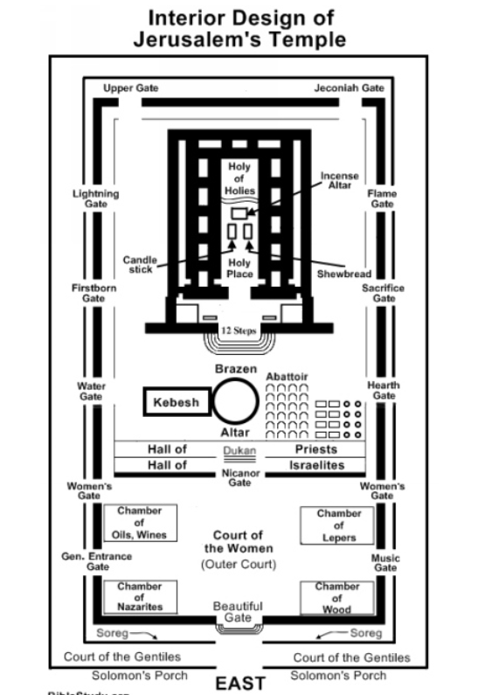

Read Numbers 15:17-21: The land of Canaan offered grazing and farming opportunities. There was a big opportunity to the faithful regardless of where they came from. God wants our first and finest as a voluntary gift of our appreciation. The first portion of the harvest was to be brought in as a sacrifice.
Read Numbers 15:22-41: There were sacrifices for unintentional sins. Intentional sins were different. There was the death penalty for intentional sins. God required the death penalty for breaking the Sabbath. Without teeth, the law would have never been established. Man will put himself into an overworked jam.
God also required that there would be a blue cord with tassels hanging from their garments, to remind them of the Law.

