Numbers 21
The children of Israel were certain that they could not enter and invade the land of Canaan. They did not believe that God would give them victory. God allowed an evil king to invade them in the desert; and help them overcome that fear. A Canaanite king of Arad came to them in the desert from across the Jordan River and raided them; and took some children of Israel as his captives. The Hebrew nation unified in prayer; and crossed into Canaan to retrieve their relatives; and then destroy the area of Hormah. Joshua’s entry near Jericho two years later was not the first entry. We can either do what God tells us the easy way; or be swept up into the forceful and unpleasant circumstances of life to accomplish the same thing.
Read Numbers 21:1-3: It is interesting that Arad was the first area repatriated by the children of Israel prior to 1948. The British mandate opened that door in 1921. Arad was also the first city/region to be taken over by the children of Israel in the time of Moses; and was also the first area to be retaken in modern times.
Hormah means to designate something for destruction (like we label medical waste). Sin is contagious. To ignore or allow sin to fester near us will eventually infect and overtake us. We need to love people; but be brutal with sin.
Read Numbers 21:4-9: The people complained about having no food and water again. They also had a huge detour because of the Edomite refusal to passage. God sent poisonous snakes to bite them; and many died.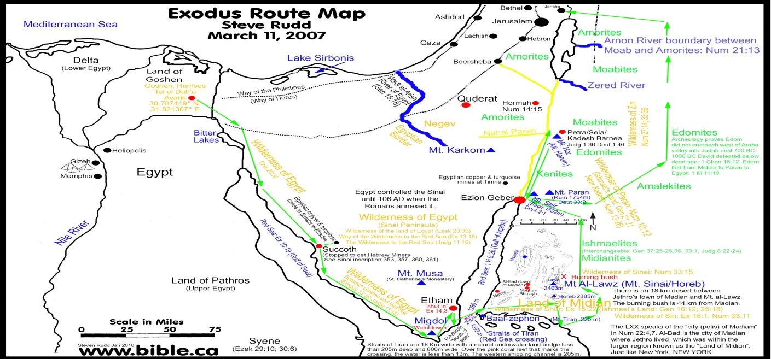
There are a few places in the Bible where having the King James Bible or the NASB are more accurate. These verses are accurately translated as fiery serpents in the King James Bible, per the original language. Other versions use venomous snakes. Is that difference in translation of any significance? The original Hebrew uses Seraph for fiery. Seraph means burning or poisonous. The word for serpent comes from a quiet hissing noise. Isaiah describes the land to the south of Israel as having fiery flying serpents.
into the land of trouble and anguish, from whence come the young and old lion, the viper and fiery flying serpent, they will carry their riches upon the shoulders of young asses, and their treasures upon the bunches of camels, to a people that shall not profit them. (Isaiah 30:6)
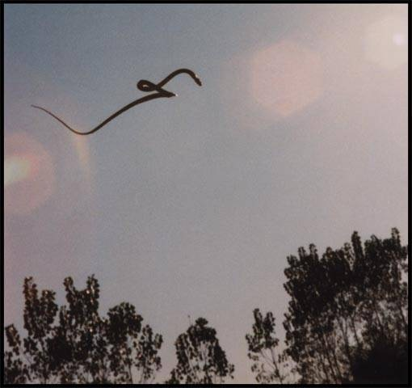
Everything was going wrong for the rebellious children of Israel. They had a big detour because of the Edomites. They complained again about wanting variety in their food; and of the water shortage. God sent poisonous snakes to bite and kill them. The people finally repented, and came to Moses to intercede in prayer for them. Moses prayed for the people. God told Moses to make a pole with a fiery serpent on it. Moses made one of bronze. God instructed Moses to have the snake-bitten people to look at the serpent on a pole to live. It worked. Whoever was bitten who looked upon the serpent on a pole was saved. The serpent was symbolic of sin and the devil. It is our own sin that kills us.
The sting of death is sin; and the strength of sin is the law. (1 Corinthians 15:56)
We have to look upon our own sin with open eyes. Healing and wholeness always begins with an accurate assessment, and intellectual honesty. We have to call for the doctor to get the help we need. Pretending that there was no correlation between their sin and their difficulties would cause death. God was forcing them to own up to the truth or die. We cannot be healed if we do not acknowledge our sin. Unless I can say publicly that I am a sinner I am still attempting to deceive.
This event provided a backdrop for a much more important life-saving event to come. Jesus became our sin; and he was lifted up on a cross.
But God commendeth his love toward us, in that, while we were yet sinners, Christ died for us. (Romans 5:8)
And as Moses lifted up the serpent in the wilderness, even so must the Son of man be lifted up: ¹⁵ That whosoever believeth in him should not perish, but have eternal life. (John 3:14-15)
Read Numbers 21:10-23: The children of Israel set out once again, heading north. They came up the back side of the mountains to Ammon and Moab (Jordan). They asked Sihon the Amorite king to allow them to pass through. Sihon refused, and came out and attacked them. They have now actually traveled past the turn off point where they would have entered Canaan. They have overshot the place to turn westward, because they were blocked. They were blocked from the south by Edom, and now they were blocked from the west by the Amorites. This is a picture of spiritual warfare. The demonic forces throw up road blocks, frustrations and fear at the entry point (doorway) of decision. The thoughts in our heads say: “Don’t go and start that project for God. You are screwing everything up!” Spiritual warfare pits us against our loved ones. It tells us that our intentions may be good; but our timing or circumstances are off. Satan uses procrastination to squelch our nagging conscience. Once we make the bold move it goes away pretty quickly. We wonder what the concern was. It is almost comical how much we sweat faith decisions; that end up being non-events. Sometimes it pays to be a little bit rash and just go for it, when we know that it is the right thing to do.
The people had repented; and they were still being attacked. Now we are moving out of the era of wilderness whining. The more that the children of Israel are attacked; the closer to God…and more thankful they become. We do need bad things to happen to us. We are like children who need to be spanked to wake up.
we also exult in our tribulations, knowing that tribulation brings about perseverance; ⁴ and perseverance, proven character; and proven character, hope; ⁵ and hope does not disappoint, because the love of God has been poured out within our hearts through the Holy Spirit who was given to us. (Romans 5:3-5)
They were slowly being conformed; but they were not ready to enter in yet. It takes a while to break old patterns of thinking. Trials and hardships are good pattern breakers. Otherwise we remain creatures of habit. It is the spiritual warfare that can transform us from being self-absorbed into people who understand that they need to support the plans of God. God will bring a battle to our front door to sober us up to a bigger reality at hand.
Read Numbers 21:24-35: The children of Israel were not looking to take the land of the Amorites. Regardless, their through-passage was not granted; and the Amorites came out and fought against Israel. The Amorites had recently taken over the neighboring Ammonite land holdings. The children of Israel defended themselves; and wiped out the Amorite forces. The children of Israel ended up taking over their land. God can use opposition and spiritual warfare to give us gifts. It is personal transformation. Our greatest gains come from our worst times.
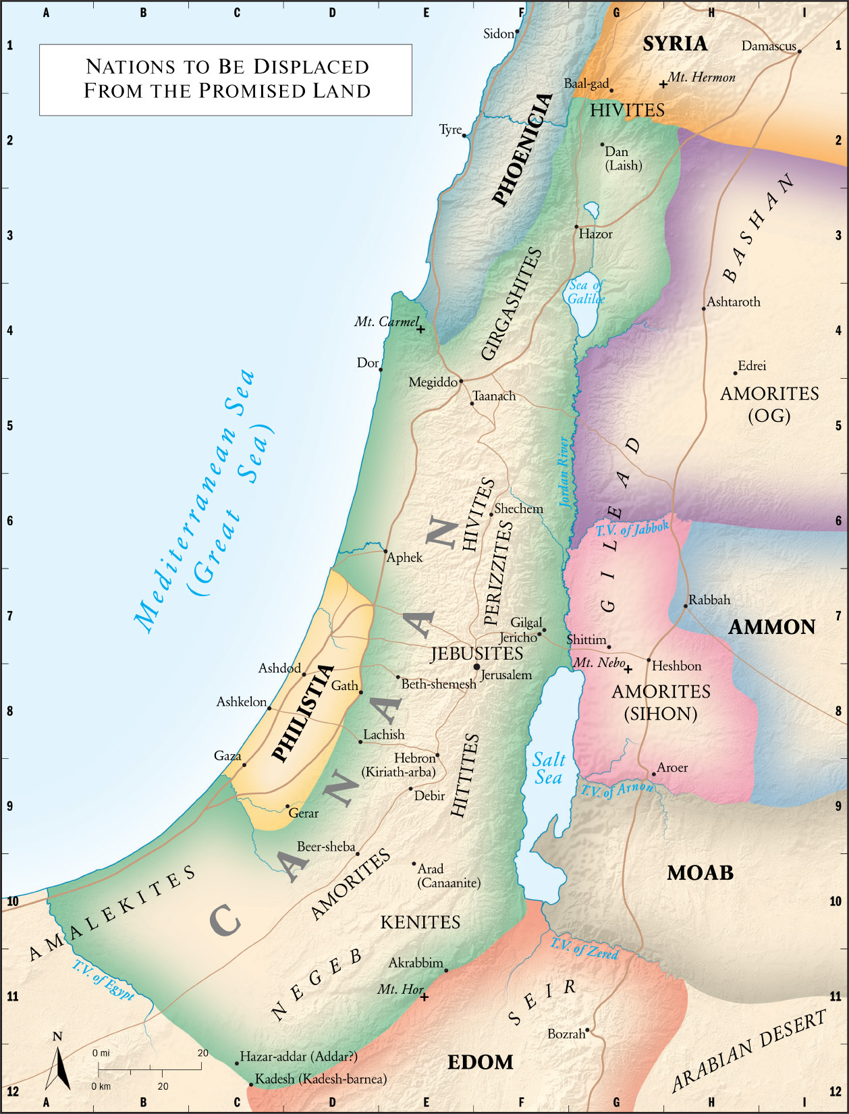

It seems like the children of Israel are literally at the doorstep of their promised land; but we are only in chapter 21 of Numbers. Numbers has some chapters devoted to short periods; and other chapters cover long periods. The first 12 chapters cover 2 months. Chapters 13-25 cover 38 years. Chapters 26-36 covered the last few months at the edge of the promised land.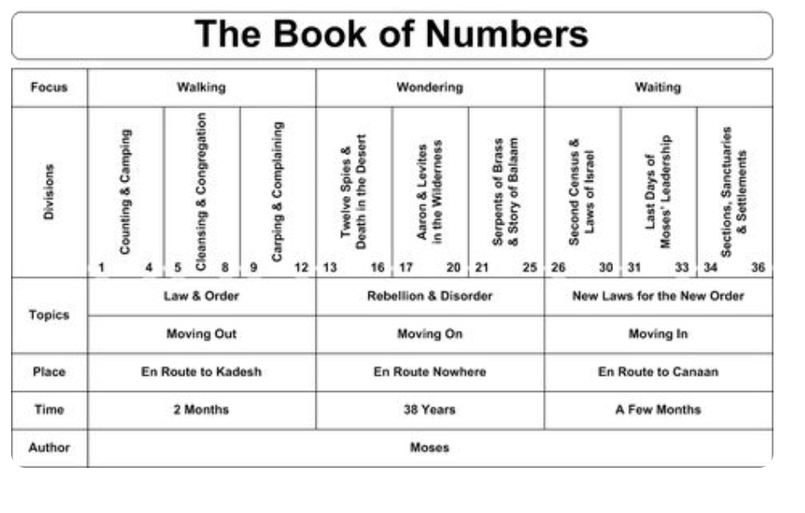
The Book of Numbers has patterns of human behavior. It was dependency on God when they were in trouble. The desire to listen to God and pursue a deeper relationship vanished when life appeared to have more options. Have you been bitten by the bitter circumstances of this life? Are you healing, with God’s help? Is your Christian walk more of a routine; then something that gets you wanting something deeper? Are you going in the same circles; but somehow expecting to see something new in your life? Recognize that the forces that come to bear in preventing you from taking the next step in faith are demonic and from our contrary flesh. The more you are afraid to step out in faith – the more that is a confirmation of direction. Every sail boat needs to head into the contrary wind to make progress, and so do we.

