Numbers 31- 35
Read Numbers 31:1-24: The people were about ready to enter a land of blessings. There are all kinds of spiritual attacks to face when we are receiving blessing. We need to keep up on our housekeeping with vigilance. Any small thing that we allow will infect us. The enemies of Israel are symbolic of our spiritual attacks. God told Moses to wipe out the Midianites with 12,000 men, and the High Priest Eleazar. This was one of his final tasks before he died. The Midianites did not want to grant them passage; and they also sought the assistance of the prophet Balaam to curse them. They were all wiped out. They also killed Balaam. Those who seek to curse us will become cursed; and we will be blessed.
The soldiers brought back the cattle, possessions and women to their camp. They also burned their cities. The homes were filled with idols; so everything seemingly useful had a contamination factor. Sometimes we think that we can use evil things for good purposes. It is better to completely dispose of all trash in our lives. Moses was upset because he had told them to utterly wipe them out. He told them to kill all of the women who had been with a man before; and kill all of the boys and baby boys; but save the little girls. Was it cruel or unforgiving to kill all of these people? We are to be loving and gentle; but that is not to be confused with allowing all things. God tells us to be ruthless with sin. The Midianites brought down the Israelites by sending their daughters to have sexual relations with the men of Israel. This broke the men’s resolve to fully follow God. Satan throws temptations at us all of the time. They come in the form of competing interests. Our hearts ca n only have one major attraction. It is necessary to not leave any door to sin cracked open… that could become a sinful resurgence. This is the history of Israel in the new land. They would let up; and allow some small enemy camp to remain (as long as they thought it was insignificant). These residual dark forces would build up, and grow to slaughter God’s people…ad create a long-term problem. Fortunately God has made the dark forces with an identifiable pattern. They do not glorify God; and they bring destruction to men’s lives. They bring men to kill others; and then take their own lives. Nationally, our country is divided and committing political suicide with self-inflicted wounds and destructive decisions.
Eleazar told the troops that they could only keep what could be completely cleansed. Every trinket and treasure had to pass through fire; and then be washed off. That would eliminate any clothing, tapestry, item of wood, etc…
Read Numbers 31:25-54: The treasure collected from the invasion was brought into a central collective. The warriors did not keep their own loot. The warriors kept half; and the rest of the congregation kept the other half. The same concept applies with missionaries. Half of the spiritual blessing goes to the missionaries, and half to the senders.
For as his share is who goes down to the battle, so shall his share be who stays by the baggage; they shall share alike. (1 Samuel 30:24)
The tribe of Levi was to receive 1/500th of the men and animals from the warriors half. The congregation then gave 1/50th to the men who served in the temple. God wants us to always give back what is given to us. We have to break that bond; and pass it on. Anything that we get too connected to can bring us harm. The army brought all of the articles of gold that were captured into the tabernacle. It makes sense that the treasure did not accumulate in the desert; to have to carry around. Likewise the livestock would have no food.
Numbers 32
Read Numbers 32:1-27: The tribes of Reuben and Gad; were ranchers. They raised livestock. The land that had been acquired in Midian (across the Jordan from the land of Canaan) was good for grazing. It had good grass and gentle rolling hills. They asked Moses to take that portion as their inheritance. Moses agreed after it was understood that they would go fight alongside with the other tribes; before settling in the outside territory. They built their cities and ranches; and then left the women and children behind to take care of the business. It is interesting that the Promised Land was on the other side of the Jordan. These tribes settled for the bird in hand instead of God’s full promises. They settled for less. Eventually these tribes fell first because they were surrounded by unbelieving Gentiles. They compromised their morals and faith like their neighbors. They eventually took on their ways; and were the first to fall to invasion.
Read Numbers 32:28-42: The half-tribe of Manasseh also was given their parcel of land near Gad and Reuben. Manasseh overthrew the Amorites; and took their land.
Numbers 33
Read Numbers 33:1-49: This section is the overall summary of encampments during the 40-year journey, as recorded by Moses.
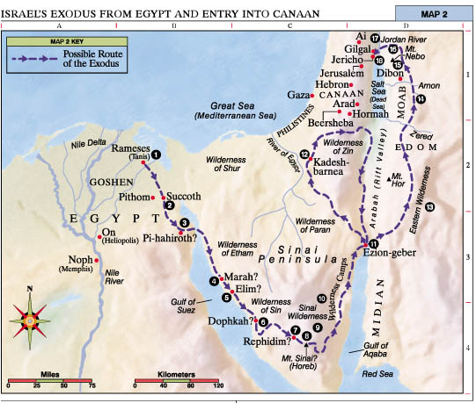
Read Numbers 33:50-56: Moses describes the re-occupation process of their home land. Not only did they have to defeat the inhabitants; but they had to destroy all of the idol-worshiping amulets, figurines, statues, altars, etc… There are a different set of temptations that come during success, than those that come when you are just trying to survive. We really have no choice but to turn to God when we have tried everything else. We can easily pray when we are uncomfortable. It is harder to remain vigilant when you have other things to do; and nothing is pressing.
God has blessed us in our land of multiple blessings. We need to be vigilant to focus on God. There is all kinds of trash on TV; and on the radio. The internet can accommodate many kinds of sins. We work and live near people who do not believe in God; and their reflects it. God does not want us to live like monks; but we have to be pro-active and on top of our spiritual life. I have seen many Christian families let their kids listen to rank music; resulting in their eventual leaving of the church. I have seen families choose to go to the beach on Sunday, instead of going to church. Eventually they stopped going to church altogether.
Therefore, thus says the Lord, “If you return, then I will restore you— Before Me you will stand; And if you extract the precious from the worthless, You will become ^{[f]}My spokesman. They for their part may turn to you, But as for you, you must not turn to them. (Jeremiah 15:19)
The remaining inhabitants who were not destroyed became the source of future wars, and continuous problems for the children of Israel.
We are getting near Moses’ last testament to the people on earth. He will rehearse the entire Law in the book of Deuteronomy, just before Joshua takes them into the new land.
We will be attacked for our faith. We will be belittled and misrepresented. It has always been that way.
“If the world hates you, ^{[e]}you know that it has hated Me before it hated you. ¹⁹ If you were of the world, the world would love its own; but because you are not of the world, but I chose you out of the world, because of this the world hates you. (John 15:18-19)
There is the outright opposition to doing things godly and decently. There is also the more covert temptations that come from what we see and what we hear. We need to protect our eye gates and our ear gates to keep sinful concepts out of our mind. We are surrounded by lures. If we allow evil messages to get into our mind they will create damage.
Read Numbers chapter 34: Today, Israel is living in a compromised boundary. They have given up land to keep their land-stealing neighbors happy. This strategy has always worked for against them. It is God’s land that was given to them as an everlasting inheritance.
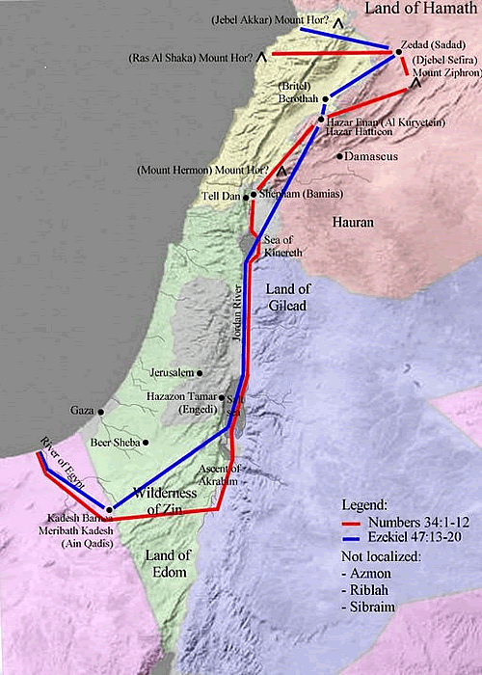
The land of Israel was specifically laid out. In the future; God will greatly increase the size of Israel.
To your descendants I have given this land, from the river of Egypt (traditionally taken as the Nile) as far as the great river, the River Euphrates (Gen 15.18)
I will fix your boundary from the Red Sea to the sea of the Philistines (Gaza coast), and from the wilderness to the River Euphrates (Exod 23.31)
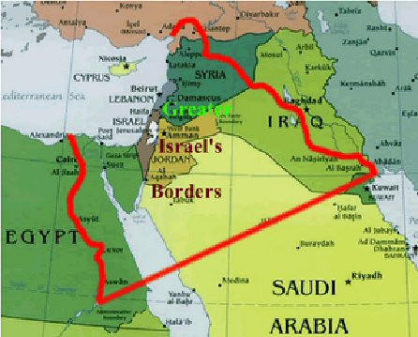
The millennial age will have Israel as the head of all nations. The people will make a journey to Jerusalem for the holy feasts or they will not get any rain.
Then it will come about that any who are left of all the nations that went against Jerusalem will go up from year to year to worship the King, the LORD of hosts, and to celebrate the Feast of Booths. (Zechariah 14:16)
And he that overcomes, and keeps my works unto the end, to him will I give power over the nations: And he shall rule them with a rod of iron; as the vessels of a potter shall they be broken to shivers: even as I received of my Father. (Revelation 2:26-27)
The peoples will take them along and bring them to their place, and the house of Israel will possess them as an inheritance in the land of the LORD as male servants and female servants; and they will take their captors captive and will rule over their oppressors. (Isaiah 14:2)
Read Numbers 35:1-15: The families of the priests were given pasture land around 48 cities in Israel. They would be given the areas from the city wall outward 3,000 feet, surrounding each city. This accounts for most of the cities. 35 cities were specifically overthrown in the land of Canaan by Joshua. There were at least 15 more captured on the opposite side of the Jordan River by Reuben, Gad and Manasseh. Additionally there were to be 6 cities of refuge given for asylum. Three were on each side of the Jordan River. The Levites would control those cities of refuge. The purpose of these cities was for a safe haven for the man who accidentally killed someone else. They would stay their protected until their trial took place. Our concept of innocence until proven guilty is the same idea. In those days a family member was appointed to avenge the blood. In other words, if your daughter was raped, your oldest son might have been chosen to assassinate him. It is also interesting that the priests were dispersed into the society, where they were accessible to the public. Those who caused manslaughter were not to be killed.
Read Numbers 35:16-21: The dividing line between manslaughter and murder are laid out here. Unintentional injury to a person is manslaughter, not murder. Having intent to harm someone by hitting them with an iron object, or a stone, or a piece of wood resulting in death is murder. In those cases the family avenger is to kill him when he meets him. If someone hated another person, and pushed them or attacked him resulting in death is murder. There is a tie to the hatred and malice.
“You have heard that ^{[k]}the ancients were told, ‘You shall not commit murder’ and ‘Whoever commits murder shall be ^{[l]}liable to the court.’ ²² But I say to you that everyone who is angry with his brother shall be ^{[m]}guilty before the court; and whoever says to his brother, ‘^{[n]}You good-for-nothing,’ shall be ^{[o]}guilty before ^{[p]}the supreme court; and whoever says, ‘You fool,’ shall be ^{[q]}guilty enough to go into the ^{[r]}fiery hell. ² (Matthew 5:21-22)
Read Numbers 35:22-28:If somebody accidently kills somebody he will be protected under manslaughter at the city of refuge. The difference between manslaughter and murder has a lot to do with intent to harm. If you swing for a guy’s head with a pipe it is at least attempted murder. If you accidently have an axe head fly off of the handle; or have a hoisted load fall it is manslaughter. The investigating priests and city leaders will look carefully at the reputation, the relationship and motives for clues.
The man may live in the city of refuge with the protection that extends to the city limits. Once the manslayer ventures out; he is a target for the manslayer. Additionally, the manslaughter person must leave the city of refuge after the High Priest dies. Why is the manslaughter perpetrator not given total immunity country-wide, since it was an accident? Why does the perpetrator lose these protections once the High Priest dies? It might be a built-in disincentive to ever be involved in manslaughter. Crafty schemes could be carefully set up to appear as manslaughter instead of murder. There is always a percentage of doubt as to the complete innocence of the perpetrator. Was the perpetrator really protecting his family from an intruder; or did he have an argument…kill the man outside…and then secretly drag him into his home? Witnesses can protect their loved ones. People can be paid off to falsify evidence. Our current legal system allows people to raise frivolous law suits without risk. Everybody claims to be a victim, until you hear the other side of the story. You can end up with cities of refuge populated by intelligent criminals who managed to spin a yarn good enough to be believed. This way there is an incentive built in to be careful when you plan your work; so as not to expose others to hazards. Negligence can play into the formula as well. What happens if you run over someone wearing black at night, who crossed the street in front of your car? These limited protections would motivate you to just drive slow enough to successfully take evasive actions.
Read Numbers 35:29-34: Murderers must be killed rapidly. There needs to be 2-3 witnesses. God’s plan requires you to face your accusers...not some attorney. Manslaughter is not murder; since there is no intent. Our current system takes the burden of doubt to a ridiculous level….and the delays distance the punishment many years from the incident. This is hurting our country.
Because the sentence against an evil deed is not executed quickly, therefore the hearts of the sons of men among them are given fully to do evil. (Ecclesiastes 8:11)
Additionally, you cannot settle for a financial settlement. Rich people cannot have any advantages.

