Numbers 8
Read Numbers 8:1-4: God gave Moses a pattern to build the menorah. It is a golden lampstand in the tabernacle that has 7 lamps. The lampstand represents different things.
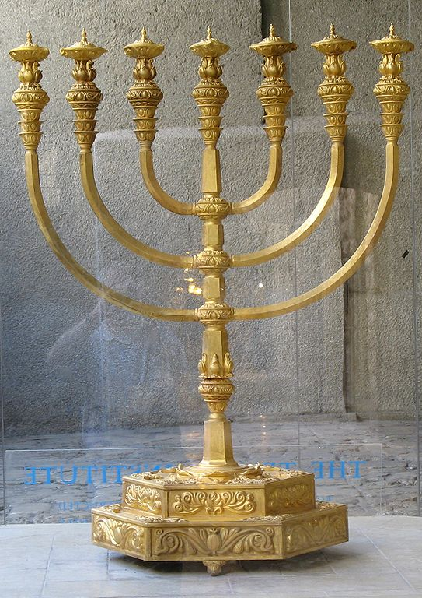
It is a burning almond tree. God is a consuming fire; and faithful men are like a tree of righteousness. Moses was amazed to see a bush burning that was not being consumed in the desert. The spirit of righteous men does not become consumed in fire. The only way that man can dwell in God’s presence is in spirit. The flesh would be consumed in an instant. The incident of the burning bush was the first time that God referred to the children of Israel as ‘my people’. To be a lamp to the world is our representation of the kingdom. To not walk by faith is to not bear light in the world.
Therefore remember from where you have fallen, and repent and do the ^{[d]}deeds you did at first; or else I am coming to you and will remove your lampstand out of its place—unless you repent. (Revelation 2:5)
Jesus is God living as a man. God’s spirit was cohabiting with humanity. Jesus is our example of a burning bush; providing light for all to see the truth. Jesus revealed himself at the Feast of Dedication (Hanukah). There would have been a large, burning menorah at the tabernacle:
At that time the Feast of the Dedication took place at Jerusalem; ²³ it was winter, and Jesus was walking in the temple in the portico of Solomon. ²⁴ The Jews then gathered around Him, and were saying to Him, “How long ^{[b]}will You keep us in suspense? If You are ^{[c]}the Christ, tell us plainly.” ²⁵ Jesus answered them, “I told you, and you do not believe; the works that I do in My Father’s name, these testify of Me. (John 10:22-25)
There are seven burning lamps on the menorah. The Holy Spirit is symbolized by tongues of fire. The Holy Spirit is described as being 7-fold as well.
…from the seven spirits^{[a]} before his throne, (Revelation 1:4)
In front of the throne, seven lamps were blazing. These are the seven spirits^{[a]} of God. (Revelation 4:5)
Jesus has a 7-fold (7-branched) spirit within him:
A shoot will come up from the stump of Jesse; from his roots a Branch will bear fruit. ² The Spirit of the Lord will rest on him— the Spirit of wisdom and of understanding, the Spirit of counsel and of might, the Spirit of the knowledge and fear of the Lord— (Isaiah 11:1)
What kind of tree is the menorah? It is an almond tree.
Make a lampstand of pure gold. Hammer out its base and shaft, and make its flowerlike cups, buds and blossoms of one piece with them. ³²Six branches are to extend from the sides of the lampstand—three on one side and three on the other. ³³Three cups shaped like almond flowers with buds and blossoms are to be on one branch, three on the next branch, and the same for all six branches extending from the lampstand. ³⁴And on the lampstand are to be four cups shaped like almond flowers with buds and blossoms. ³⁵One bud shall be under the first pair of branches extending from the lampstand, a second bud under the second pair, and a third bud under the third pair—six branches in all. ³⁶The buds and branches shall be all of one piece with the lampstand, hammered out of pure gold. ³⁷Then make its seven lamps and set them up on it so that they light the space in front of it. ³⁸Its wick trimmers and trays are to be of pure gold. ³⁹A talent of pure gold is to be used for the lampstand and all these accessories. ⁴⁰See that you make them according to the pattern shown you on the mountain.^{[1]}(Exodus 25:31-40)
The almond tree may have been selected for a number of reasons. The Hebrew word for almond means to watch or (ready to go). It implies true believers are not mindlessly conforming to a drill. They live in a state of readiness. The Parable of the Ten Virgins was all about how true believers are paying attention and ready to go.
“Then the kingdom of heaven will be comparable to ten virgins, who took their lamps and went out to meet the bridegroom. ² Five of them were foolish, and five were prudent. ³ For when the foolish took their lamps, they took no oil with them, ⁴ but the prudent took oil in flasks along with their lamps. ⁵ Now while the bridegroom was delaying, they all got drowsy and began to sleep. ⁶ But at midnight there was a shout, ‘Behold, the bridegroom! Come out to meet him.’ ⁷ Then all those virgins rose and trimmed their lamps. ⁸ The foolish said to the prudent, ‘Give us some of your oil, for our lamps are going out.’ ⁹ But the prudent answered, ‘No, there will not be enough for us and you too; go instead to the dealers and buy some for yourselves.’ ¹⁰ And while they were going away to make the purchase, the bridegroom came, and those who were ready went in with him to the wedding feast; and the door was shut. ¹¹ Later the other virgins also came, saying, ‘Lord, lord, open up for us.’ ¹² But he answered, ‘Truly I say to you, I do not know you.’ ¹³ Be on the alert then, for you do not know the day nor the hour. (Matthew 25:1-13)

The almond is one of the most-beautiful trees in the Middle East when it is in blossom. The almond bud and blossom are used to illustrate God’s timing and unseen clock. The almond appears to be lifeless (like all deciduous trees in winter) until the buds suddenly begin to swell on the branches. At some mysterious and unknown day annually in the spring the buds swell and produce flowers. What a beautiful thing it is to see God’s hidden anointing on his servants.
The almond is known for its fruitfulness; because God has anointed it to produce almonds. We cannot produce spiritual fruit in the flesh. Neither does the almond. It does not produce a valuable flesh (like a peach). It produces a precious seed to consume. We pass on faith (God’s seed). God has designated certain men to produce fruit. Moses, Aaron and the tribe of Levi were set apart as God’s choice for his priestly-representatives. All of the other tribes were not created to fulfill the role of the priest. That role was challenged by large contingent of Israeli leadership of other tribes, led by a man named Korah.
Korah an 250 Israeli leaders said to Moses and Aaron: “You have gone too far! The whole community is holy, every one of them, and the Lord is with them. Why then do you set yourselves above the Lord’s assembly?” (Numbers 16)
So Moses spoke to the Israelites, and their leaders gave him twelve staffs, one for the leader of each of their ancestral tribes, and Aaron’s staff was among them. ⁷ Moses placed the staffs before the Lord in the tent of the covenant law. ⁸ The next day Moses entered the tent and saw that Aaron’s staff, which represented the tribe of Levi, had not only sprouted but had budded, blossomed and produced almonds. (Numbers 17:6-8)
This rod of Aaron that blossomed and bore fruit was placed in the Ark of the Covenant as a perpetual statement from God. The rods (tribal icon) of the men of the other tribes did not bud or produce fruit.
The area in Israel called Luz is the word for the wild almond. Jacob had a vision of the stairway to heaven at Bethel (which is essentially the same location as Luz).

Read Numbers 8:5-13: The Levite priests were a proxy for all of the children of Israel. The people laid their hands on the dedicated priests for a reason. It was transference of representation (like a senator). A priest was to bring all of the people’s concerns and issues to God. When a community laid hands on an apostle, it was to authorize that person to carry out their desires and representation abroad. It was also to pray for God to bless them. This sense of a connection to our brothers is a lost concept in western culture. We do not authorize anybody to speak for us. We do not trust our neighbor; and we have no desire to speak on their behalf. We are not invested in our neighbor. We are more caught up into fear of misrepresentation and personal ambition. Middle Eastern communities see their neighbor as a representation of themselves.
In the same way, the priest would lay his hands on the head of an animal to be sacrificed. That was the symbolic transfer of sin from the people to the animal. He animal would then be killed for men’s sins.
The priests were shaved from head to toe. Their clothes were washed. It was a fresh start. The entire country would be involved in the swearing in of a new priest because their lives were essentially in his hands before God.
Read Numbers 8:14-19: God considered the tribe of Levi to be his own. They were focused and tasked with protecting the rest of the nation against plagues of any kind. This is called intercession and common grace. Intercession is our responsibility as priests to pray for our nation, and our neighbors. Common grace are the blessings that non-believers have merely by living by a believer.
For the unbelieving husband is sanctified through his wife, and the unbelieving wife is sanctified through ^{[h]}her believing husband; for otherwise your children are unclean, but now they are holy. (1 Corinthians 7:14)
But I say to you, love your enemies and pray for those who persecute you, ⁴⁵ so that you may ^{[ap]}be sons of your Father who is in heaven; for He causes His sun to rise on the evil and the good, and sends rain on the righteous and the unrighteous. (Matthew 5:44-45)
If I shut up the heavens so that there is no rain, or if I command the locust to devour the land, or if I send pestilence among My people, ¹⁴ and My people ^{[d]}who are called by My name humble themselves and pray and seek My face and turn from their wicked ways, then I will hear from heaven, will forgive their sin and will heal their land. (2 Chronicles 7:13-14)
Read Numbers 8:20-22: The Levite priests were dedicated and ceremonially purified. Then they were presented to God as a wave offering. What is a wave offering? It is like tithing. It is giving of the first fruits of your harvest. The omer offering was a grain sacrifice wave offering, brought to the temple in Jerusalem. The Feast of First Fruits is a holy holiday involving a sheaf of barley which was offered in connection with the Feast of Unleavened Bread, directly following the Passover. The first-fruits of the second harvest, the loaves of bread, are offered at Shavuot, and both were wave offerings. The Levitical priests themselves were also offered to God by Aaron as a wave offering.^{[2]}
Then the Lord spoke to Moses, saying, “Speak to the sons of Israel and say to them, ‘When you enter the land which I am going to give to you and reap its harvest, then you shall bring in the sheaf of the first fruits of your harvest to the priest. He shall wave the sheaf before the Lord for you to be accepted; on the day after the sabbath the priest shall wave it. ( Leviticus 23:9-11)
Jesus is considered the first fruit of resurrected men. He is the first one to enter heaven as a man. Before his crucifixion saints went to Abraham’s bosom (paradise). Then he led them from paradise to heaven.
Therefore ^{[a]}it says, “When He ascended on high, He led captive a host of captives, And He gave gifts to men.” ⁹ (Now this expression, “He ascended,” what ^{[b]}does it mean except that He also ^{[c]}had descended into the lower parts of the earth? ¹⁰ He who descended is Himself also He who ascended far above all the heavens, so that He might fill all things.) (Ephesians 4:8-10)
But now Christ has been raised from the dead, the first fruits of those who are asleep. ²¹ For since by a man came death, by a man also came the resurrection of the dead. ²² For as in Adam all die, so also in ^{[h]}Christ all will be made alive. ²³ But each in his own order: Christ the first fruits, after that those who are Christ’s at His coming, (1 Corinthians 15:20-23)
Read Numbers 8:23-50: The Levites had a period of active duty from age 25 through age 50. They were able to support and help out after age 50; but no official priestly duties. The Bible does not advocate ever retiring from serving God. King David and Samuel served as long s their body held out. There were a lot of other men who needed a chance to serve.

