Ezekiel 41-42
We are continuing to lay out the millennial temple; which is much larger than any temple made by man. We see an angel laying it out. We assume that God instantly makes it. Today we are going to go inside some spaces and try to give it some relatability.
Read Ezekiel 41:1-4: The sanctuary is broken down into the Holy Place and the Holy of Holies (Most Holy Place). The Holy Place had the table of showbread, the golden altar of incense, and the menorah. The Most Holy Place (Holy of Holies) had the ark of the covenant. Only the High Priest was allowed into the Holy of Holies in the past. Now, there is no curtain for separation.
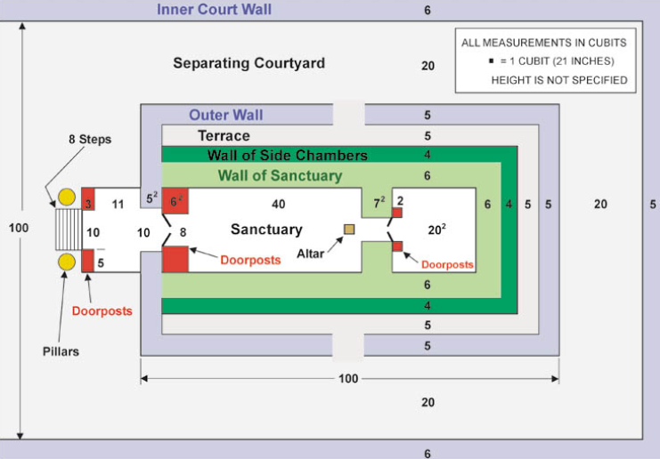
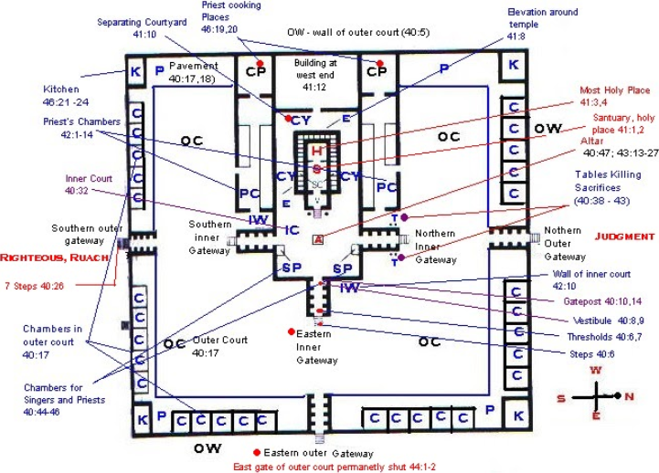
Read Ezekiel 41:5-11: The wall separating the sanctuary from the bedrooms and the storage rooms was 10 ½' high and 10 ½' thick. The side chambers were 3 levels high. The higher rooms were narrower than the rooms below. The bottom floor rooms were 9’ wide and 10’ high. These rooms were used for storage, articles of worship, and they have windows for ventilation. The chambers were accessible to the courtyard. They speak of support and organization.
Read Ezekiel 41:12-26: The chambers and sanctuary combined structure had a separating terrace to the inner courtyard. The building was 122.5’ wide and 175eet long. Take a moment to watch the following videos:
- The Temple Tour-Part 1
- The Temple Tour-Part 2
- The Temple Tour-Part 3
- The Veilless Temple
https://millennialreign.org/courses/introduction-and-approach-to-the-millennial-temple-with-dr-charles-ruark/
We read about cherubim and palm trees throughout.
Read Ezekiel 42: Now we read about who is which quadrant of the building. Please click on this link to see each dimension as you walk through the facility.
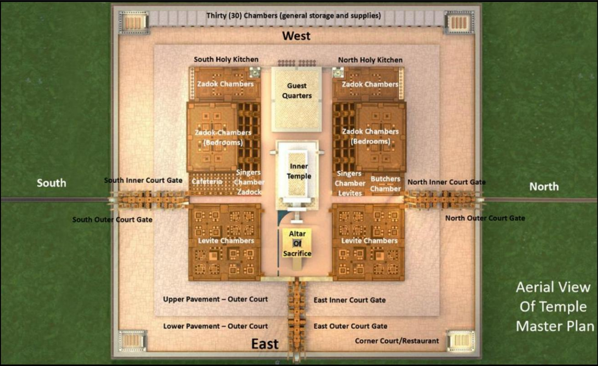
https://youtu.be/YNmERZkT6JM
