Mark 13

Read Mark 13:1-4: This is the same material that we have in Matthew 24. There is such a contrast between what is impressive to man verses what God cares about. The disciples marveled over the engineering feat in Herod’s temple in Jerusalem. The smaller carved stones weighed 1-2 tons. The larger stones weighed 10-20 tons. The largest stones were around 570 tons. These stones were made in precision and somehow moved into place.
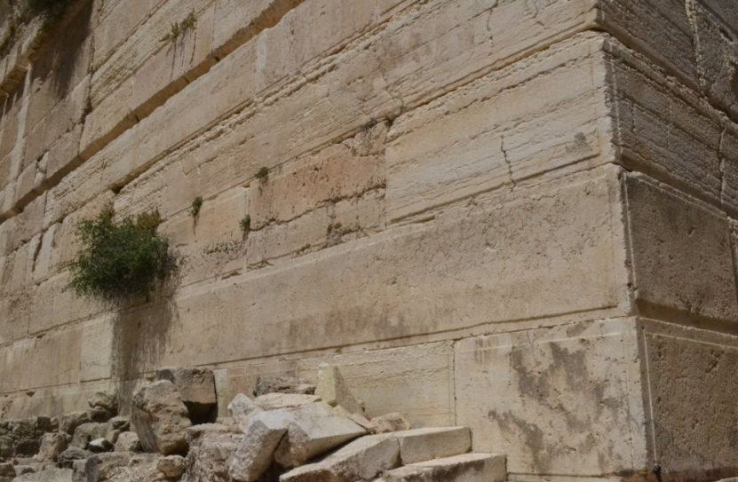

Herod was an evil man who wanted to obtain Jewish support during his reign over them, under the Roman Empire. There was no worship or adoration of God associated with the Herodian Temple. It was just a source of national pride. God was much more impressed with the tiny second temple of Zerubbabel, when the Jews returned from Babylonian captivity. Some of the Jews cried because it was so much smaller than Solomon’s Temple. God only saw the longing hearts to reconnect with God.
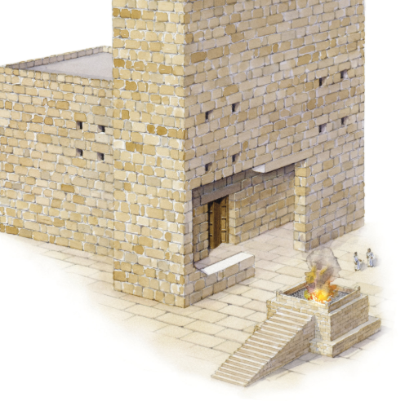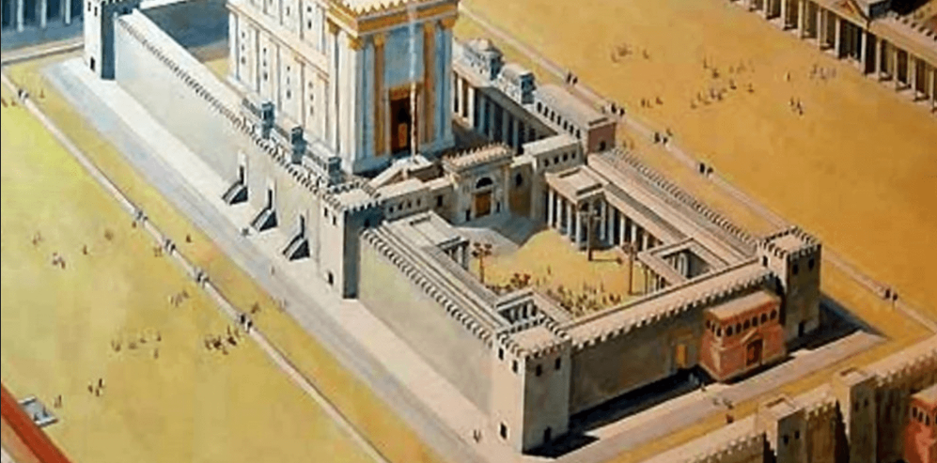
¹⁰ When the builders laid the foundation of the temple of the Lord, the priests in their vestments and with trumpets, and the Levites (the sons of Asaph) with cymbals, took their places to praise the Lord, as prescribed by David king of Israel. ¹¹ With praise and thanksgiving they sang to the Lord: “He is good; his love toward Israel endures forever.” And all the people gave a great shout of praise to the Lord, because the foundation of the house of the Lord was laid. ¹² But many of the older priests and Levites and family heads, who had seen the former temple, wept aloud when they saw the foundation of this temple being laid, while many others shouted for joy. ¹³ No one could distinguish the sound of the shouts of joy from the sound of weeping, because the people made so much noise. And the sound was heard far away. (Ezra 3)

⁴ I asked the angel who talked with me, “What are these, my lord?” ⁵ He answered, “Do you not know what these are?” “No, my lord,” I replied. ⁶ So he said to me, “This is the word of the Lord to Zerubbabel: ‘Not by might nor by power, but by my Spirit,’ says the Lord Almighty. ⁷ “What are you, mighty mountain? Before Zerubbabel you will become level ground. Then he will bring out the capstone to shouts of ‘God bless it! God bless it!’” ⁸ Then the word of the Lord came to me: ⁹ “The hands of Zerubbabel have laid the foundation of this temple; his hands will also complete it. Then you will know that the Lord Almighty has sent me to you. ¹⁰ “Who dares despise the day of small things, since the seven eyes of the Lord that range throughout the earth will rejoice when they see the chosen capstone in the hand of Zerubbabel?” (Zechariah 4)

Jesus told them that Herod’s temple would be completely dismantled. Apparently in 70 AD the Roman soldiers who were instructed in knocking it down wanted the melted gold that was in between the stones.
The idea was that the Jews had rebelled against Rome, and they were being put in their place for this revolt. The temple was their national identity. Rome wanted to break them. Rome had controlled Jerusalem since 63 AD. The Roman taxation created a lot of tension. The corrupt Roman governors also aggravated the locals. In AD 66 there were numerous Jewish outbreaks and revolts. The Romans had seized the temple funds; which made the Jews go crazy. In 67 Vespasian sent troops to put down the rebellion. He besieged Jerusalem in AD 70 and really wiped out the entire city; where 1.1 million Jews were killed and 97,000 were sold into slavery. Jesus predicted this here 30+ years in advance. It happened in that same generation. Jesus was talking about much more than the near-term fulfillment of that prophecy. The unholy temple had become a contradiction.
Jesus's criticism of Temple practices suggests that institutional aspects had become disconnected from spiritual intent. The Gospels record Jesus overturning money changers' tables and criticizing how the Temple had become a commercial operation. He emphasized that authentic worship and God's presence couldn't be confined to a building—"where two or three gather in my name, there am I with them" (Matthew 18:20).
The Pharisees and scribes were sometimes portrayed in the Gospels as overly focused on Temple regulations and ritual purity rather than on mercy, justice, and love of neighbor—suggesting that adherence to Temple-centered practice had sometimes replaced ethical focus.
Emphasis on material grandeur: Herod the Great had magnificently expanded and beautified the Temple, making it one of the architectural wonders of the ancient world. Some sources suggest that pride in this building's splendor may have occasionally overshadowed focus on the divine reality it supposedly represented.
Read Mark 13:5-19: Like much prophecy, Jesus now expands the focus from things happening in Jerusalem in that generation. Now he echoes what will happen in the Great Tribulation. One of the first precursors to the tribulation will be false messiahs. Today, we have our share of cults. We have Mormonism, Jehova’s Witnesses, plus all of the idols, like Islam, Buddhism, etc… What this is suggesting is some pretty authentic-looking false Christ’s. The scriptures tell us that only the Holy Spirit can help a person discern these phonies.
Dear friends, do not believe every spirit, but test the spirits to see whether they are from God, because many false prophets have gone out into the world. ² This is how you can recognize the Spirit of God: Every spirit that acknowledges that Jesus Christ has come in the flesh is from God, ³ but every spirit that does not acknowledge Jesus is not from God. This is the spirit of the antichrist, which you have heard is coming and even now is already in the world. (1 John 4:1-3)
²² “If those days had not been cut short, no one would survive, but for the sake of the elect those days will be shortened. ²³ At that time if anyone says to you, ‘Look, here is the Messiah!’ or, ‘There he is!’ do not believe it. ²⁴ For false messiahs and false prophets will appear and perform great signs and wonders to deceive, if possible, even the elect. ²⁵ See, I have told you ahead of time. ²⁶ “So if anyone tells you, ‘There he is, out in the wilderness,’ do not go out; or, ‘Here he is, in the inner rooms,’ do not believe it. ²⁷ For as lightning that comes from the east is visible even in the west, so will be the coming of the Son of Man. ²⁸ Wherever there is a carcass, there the vultures will gather. (Matthew 24)
⁵ Don’t you remember that when I was with you I used to tell you these things? ⁶ And now you know what is holding him back, so that he may be revealed at the proper time. ⁷ For the secret power of lawlessness is already at work; but the one who now holds it back will continue to do so till he is taken out of the way. (2 Thessalonians 2)
The next thing that will happen is that nations and people groups will go to arms against each other everywhere. The earthquakes will also become a much bigger deal than before. Christianity will be outlawed, and evangelists will punish you and arrest you. This is all at the beginning of the 7-year tribulation. Family loyalty and family structure will fall apart. Parents and children will sell each other out. It will be a dog-eat-dog world. To be a Christian in those days will entail that everyone will hate you.
The Abomination that causes desolation is the antichrist seated in the holy of holies in the newly-rebuilt temple in Jerusalem. That marks the midpoint of the tribulation, and the demarcation of the ultra-severe great tribulation final 3 ½ year period. The Jews are told to flee to Petra, Jordan and hide the second you hear about this. Jerusalem will be invaded to kill all of the Jews. That last 3 ½ years of tribulation will be the worst time on earth. 1/3 of all men and 2/3 of the Jews will be killed.
Read Mark 13:20-37: After the natural and political forces give way, the universe itself will become unstable. There will be major impacts from falling stars and asteroids hitting earth. The orbit of the earth and its relationship to the sun and moon will shift and become unstable.
Nobody knows when the tribulation will end, signaling the return of Jesus. He will return as all hell has broken loose on the earth. The point is to pay attention to where we are in relation to prophetic fulfillment.

