Mark 14

What is Passover? Is it Easter? The Hebrews were delivered from the Egyptian slavery of 400 years by God’s mighty hand. God used this rescue to show all of the nations that the God of the Hebrews delivers his own helpless people from all of the so-called gods and mighty men. God’s methodology was to kill a lamb for each protected household and smear the blood all over the front door. When the death angel passed over each house, he would not stop where there was evidence that the required death had already taken place.
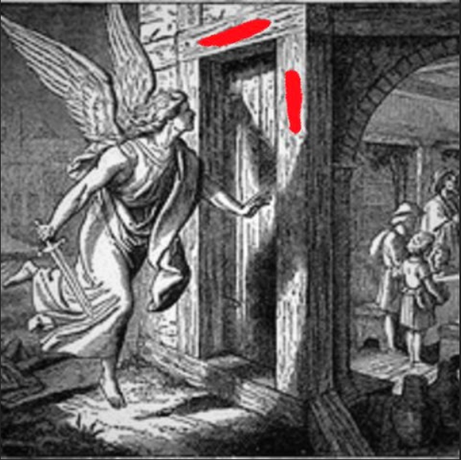
The separation between God and men is the most important issues in the universe. We know that Jesus was pre-ordained to be the sacrificial lamb who takes away the sin of the world. The Passover is the memorial for that momentous event. The Old Testament is a great record of how necessary it was to get around any performance-based salvation for mankind. This chapter puts the love of Jesus juxtaposed to the heartless posers, who were trying to commandeer the Kingdom of God for themselves.

Read Mark 14:1-2: The chief priests desperately wanted to hide their evil works from the public. Jesus was like a flashlight in a dark place. They wanted to shut him up forever. Jesus was exposing their fraud and their gross misrepresentation of God’s Kingdom. Moreover, the common people liked him better than them. Jesus operated in love; but they operated with intimidation. It is interesting how liars have to resort to intimidation and limited visibility.
²⁷ “Woe to you, scribes and Pharisees, hypocrites! For you are like whitewashed tombs which indeed appear beautiful outwardly, but inside are full of dead men’s bones and all uncleanness. ²⁸ Even so you also outwardly appear righteous to men, but inside you are full of hypocrisy and lawlessness. (Matthew 23)
And this is the condemnation, that the light has come into the world, and men loved darkness rather than light, because their deeds were evil. ²⁰ For everyone practicing evil hates the light and does not come to the light, lest his deeds should be exposed. (John 3)
It is estimated that between 100,000 – 300,000 people would come to observe Passover at that time. Arresting the popular Galilean healing rabbi (Jesus) would have upset the crowds.
Read Mark 14:3-11: Our spending patterns and use of money reflect our priorities. Money can be used to bless others or ourselves. For where your treasure is, there your heart will be also.
²² “The eye is the lamp of the body. If your eyes are healthy, your whole body will be full of light. ²³ But if your eyes are unhealthy, your whole body will be full of darkness. If then the light within you is darkness, how great is that darkness!
²⁴ “No one can serve two masters. Either you will hate the one and love the other, or you will be devoted to the one and despise the other. You cannot serve both God and money. (Matthew 6)
The activities of Jesus and the religious leaders, could not have been more different. The religious leaders were calculating as to how they could leverage influence on Rome to condemn Jesus of some capital crime. Jesus was dining with the poor and lepers, without regard to the plot being formed. They were pouring their prime time and earnings into the Kingdom and honoring Jesus.
We see the top and the bottom of society at the same time. There are reasons that poverty lends itself to salvation opportunities more than wealth. Jesus knew well in advance what was coming his way. Jesus’ companions were not people concerned about status and wealth. The woman who poured the spikenard perfume on Jesus' head spent the equivalent of $25,000. She dumped her life savings for a chance to bless Jesus. Spiritual living really includes more savoring and reflection, and less anxiousness.
There is always something to worry about. That never stops. We can either worry or pray. Amongst Jesus’ own staff, there was a sellout thief. It happens. We work for God’s pleasure, not appreciation or loyalty from others. God knows all about it.
This is a good illustration of the two worlds clashing. One team is dead set on winning and staying in power; while the other team is more concerned about doing what is right and experiencing God.
Read Mark 14:12-26: The Exodus story highlights the Passover Lamb. On one hand it is a commemoration of the original Exodus. That is just the foreshadowing of the real Passover Lamb.
Plans are now being made to kill Jesus, the real Passover Lamb. The blood of Jesus paid for the sin penalty for all of us; making us free men.
Sometimes studying the bible can be more interesting to find the story within the story. Who was this mystery man carrying a pitcher of water? Sometimes these anonymous, yet instrumental biblical characters can reflect the Holy Spirit or angelic assistance. God uses seemingly chance-encounters all of the time. This guy must have been a friendly and engaging person who had a conversation with them. He set up a special room ready for the disciples and Jesus to dine and recline. If we are obedient to God’s commands, things magically come together in unforeseen ways. God just wants a full effort. He will provide the desired result.
The first day after the Passover (1st day of Feast of Unleavened Bread) includes a tradition of cleaning up and having a house clean of any leaven (decaying yeast). Leaven is symbolic of sin; because it is a puffing up and seeming to be more than you are. That is why the Pharisees and Chief Priests were compared to leaven. They were so fixated on their reputation and standing. Jesus sent two disciples out to find an uncontaminated place for the team to quietly commune with God. Similarly, God has a guest room set up for us up in heaven; much like this upper room. All that we want is to be with Jesus, while surrounded with God-loving brothers and sisters.
“Let not your heart be troubled; you believe in God, believe also in Me. ² In My Father’s house are many mansions; if it were not so, I would have told you. I go to prepare a place for you. ³ And if I go and prepare a place for you, I will come again and receive you to Myself; that where I am, there you may be also. (John 14)
Jesus did not turn Judas away, despite knowing that he was a sellout. Jesus allowed him to dine with him, without public humiliation. Judas greatly regretted his poor choice to betray Jesus. It is interesting how many people commit suicide after being driven by demonic powers to bring harm to others.
The communion elements that we partake in represent the body and blood of Jesus. To eat his bread is like eating his body, in that the Jews believe that you are what you eat. Jesus was broken (physically dismantled) for us. The matzah is pierced and has stripes, like Jesus was on the cross.


The food elements of Jesus body (as bread) get broken down and are used to build my body. In a sense, this makes us one, molecularly. We literally have to digest God’s word to get stronger and healthier. In fact the word used to meditate on God’s word is the word used to ruminate (keep re-chewing and re-swallowing until you get all of the nutrients out of it).
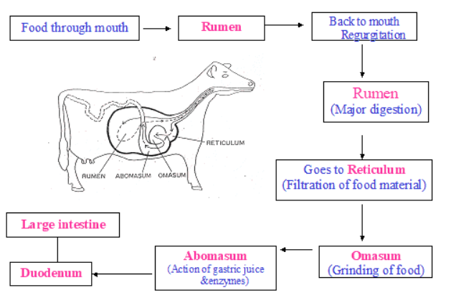
It is like the oneness of fellowship with God and receiving his strength inside of us. To drink his blood is to internalize the precious blood shed by Jesus to pay for our sins on the cross. It is to take ownership of this extreme and costly act done on my behalf. It is like returning to the scene of an automobile fatality to pay respects to the man who stepped out in front of a car to protect me. Either way, God requires that whoever sins pay for it.
¹¹ For the life of the flesh is in the blood, and I have given it to you upon the altar to make atonement for your souls; for it is the blood that makes atonement for the soul.’ (Leviticus 17)
God prioritizes this act of having our sins covered being more important than even knowing God well. Knowing God well is the second priority.
For You have magnified Your word above all Your name (Psalm 138:2)
What songs/psalms were sung at this time? Psalms 113-118. See below. It seems appropriate.
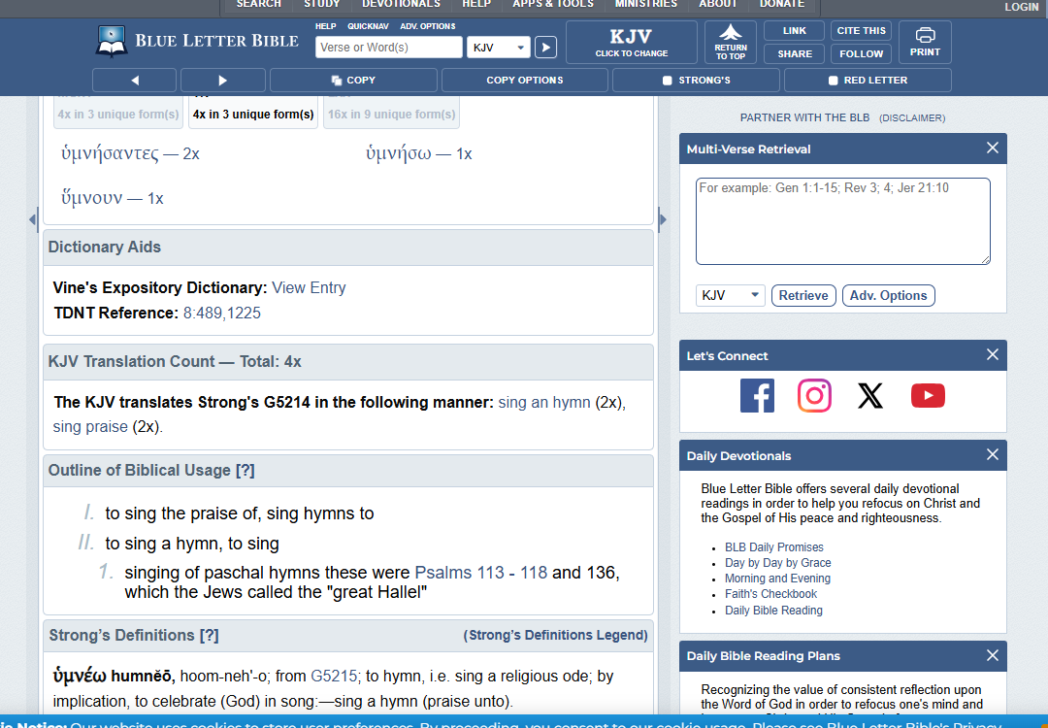

I love the Lord, because He has heard My voice and my supplications. ² Because He has inclined His ear to me, Therefore I will call upon Him as long as I live. ³ The pains of death surrounded me, And the pangs of Sheol laid hold of me; I found trouble and sorrow. ⁴ Then I called upon the name of the Lord: “O Lord, I implore You, deliver my soul!” (Psalm 116 intro)

Read Mark 14:27-31: How did this prophecy of Jesus meeting his disciples in Galilee after his resurrection from the dead play out. This is where he gives the Great Commission. To become appointed they had to show a little effort and follow through.
¹⁶ Then the eleven disciples went to Galilee, to the mountain where Jesus had told them to go. ¹⁷ When they saw him, they worshiped him; but some doubted. ¹⁸ Then Jesus came to them and said, “All authority in heaven and on earth has been given to me. ¹⁹ Therefore go and make disciples of all nations, baptizing them in the name of the Father and of the Son and of the Holy Spirit, ²⁰ and teaching them to obey everything I have commanded you. And surely I am with you always, to the very end of the age.” (Matthew 28)
God is telling us plainly that he is the one who struck his own Good Shepherd; the protector of our souls. It was not Satan or his demons; though they gladly played their parts. It was not the Jews or the Romans, though they also played their parts to a tee. Technically it was you and me who caused it.
²² “Men of Israel, listen to these words: Jesus the Nazarene, a Man attested to you by God with miracles and wonders and signs which God performed through Him in your midst, just as you yourselves know— ²³ this Man, delivered over by the predetermined plan and foreknowledge of God, you nailed to a cross by the hands of godless men and put Him to death. (Acts 2)
¹⁷ If you address as Father the One who impartially judges according to each one’s work, conduct yourselves in fear during the time of your stay on earth; ¹⁸ knowing that you were not redeemed with perishable things like silver or gold from your futile way of life inherited from your forefathers, ¹⁹ but with precious blood, as of a lamb unblemished and spotless, the blood of Christ. ²⁰ For He was foreknown before the foundation of the world, but has appeared in these last times for the sake of you (1 Peter 1)
Jesus needed to humble Peter. Peter wanted to be large and in charge. He needed to realize that he is just lucky to be on the team at all.
Read Mark 14: 32-41: The bible uses a lot of imagery to paint a picture of what is happening. Gethsemane is the word for olive press. It is fitting to see what this man is made of. What do you do when you are crushed and squeezed hard by life and circumstances? Jesus was becoming sin for men. This was the most disgusting thing that repulsed him. Jesus was about to have his father in heaven turn his back on him and break fellowship; which had neve ever happened. His flesh was about to be tortured to the maximum possible. We only think of the physical pain.
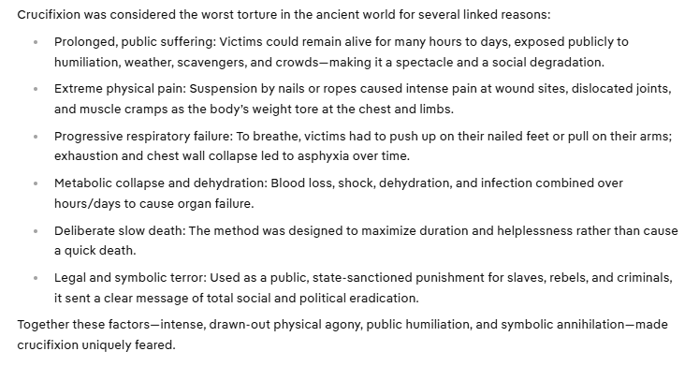
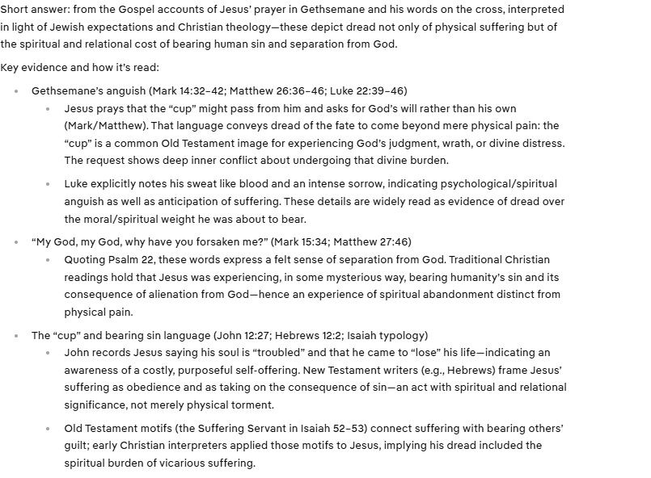
Jesus was so stressed out that he was sweating blood. He did not curse or quit.
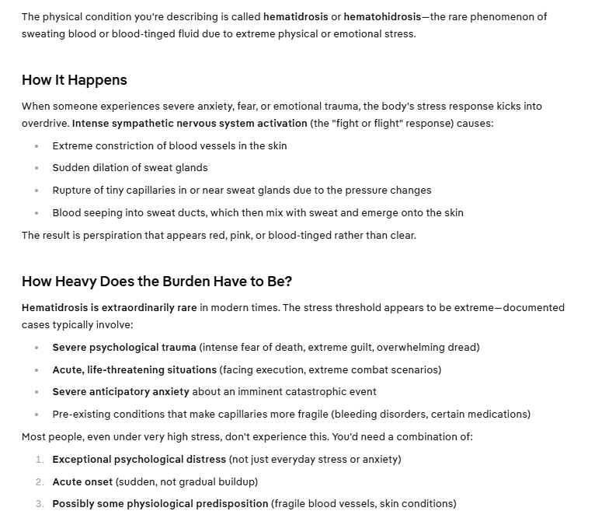
This act of self-sacrifice puts Jesus in a league by himself. It is completely different than fighting evil. He is sacrificing himself for his team.
God, after He spoke long ago to the fathers in the prophets in many portions and in many ways, ² in these last days has spoken to us in His Son, whom He appointed heir of all things, through whom He also made the world. ³And He is the radiance of His glory and the exact representation of His nature, and upholds all things by the word of His power. When He had made purification of sins, He sat down at the right hand of the Majesty on high, ⁴ having become so much better than the angels, to the extent that He has inherited a more excellent name than they. ⁵ For to which of the angels did He ever say, “You are My Son, Today I have fathered You”? And again, “I will be a Father to Him And He will be a Son to Me”? ⁶ And when He again brings the firstborn into the world, He says, “And let all the angels of God worship Him.” ⁷ And regarding the angels He says, “He makes His angels winds, And His ministers a flame of fire.” ⁸ But regarding the Son He says, “Your throne, God, is forever and ever, And the scepter of righteousness is the scepter of His kingdom. ⁹ You have loved righteousness and hated lawlessness; Therefore God, Your God, has anointed You With the oil of joy above Your companions.” ¹⁰ And, “You, Lord, in the beginning laid the foundation of the earth, And the heavens are the works of Your hands; ¹¹ They will perish, but You remain; And they all will wear out like a garment, ¹² And like a robe You will roll them up; Like a garment they will also be changed. But You are the same, And Your years will not come to an end.” ¹³ But to which of the angels has He ever said, “Sit at My right hand, Until I make Your enemies A footstool for Your feet”? (Hebrews 1)
Jesus was teaching us that we really need to be praying for those in need.
Read Mark 14:43-51: This is John-Mark’s account of the gospel. Mark was a disciple of Peter. He was around 20 years old. He saw Judas kiss Jesus, which was the sign to the ambush posse of guards. The temple police were central to this dirty deed.
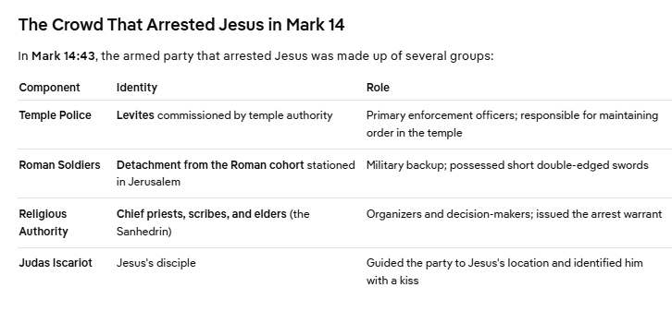
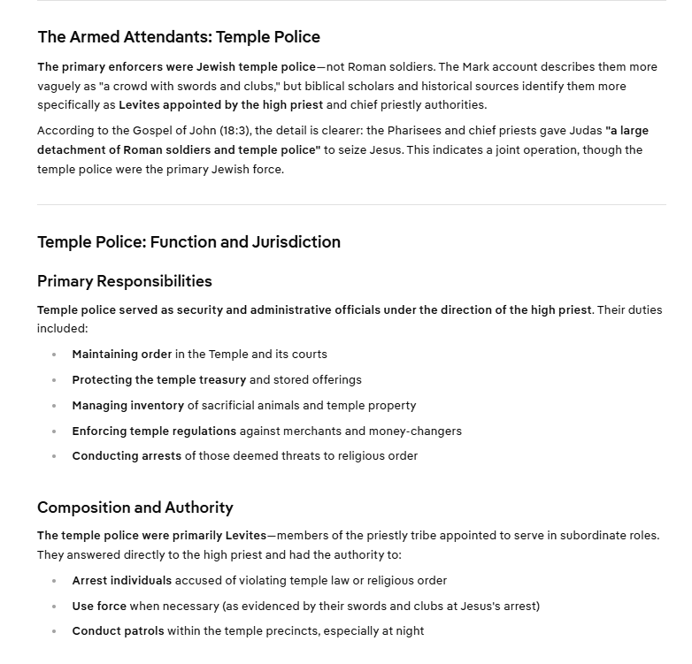
Jesus uses this dark hour to illustrate a point that the Holy Spirit prevented Jesus’s arrest until the appointed time (dark hour). Jesus was in plain site up to that time. Jesus spoke clearly and openly and did not hide. They wanted to secretly capture him when the Heavenly Father said it was time.
Read Mark 14:53-72: There were so many laws broken in the process of condemning Jesus. The whole thing was a kangaroo court in every way.
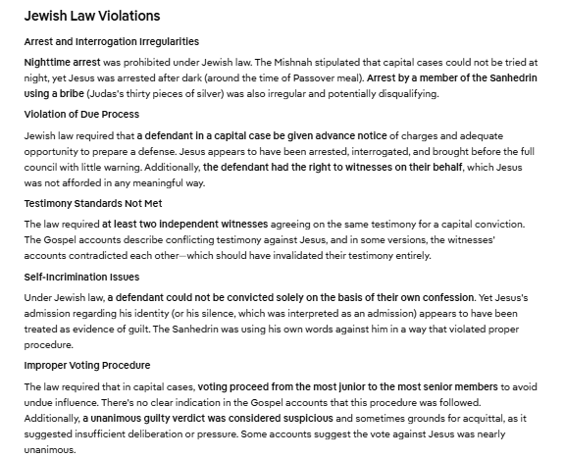
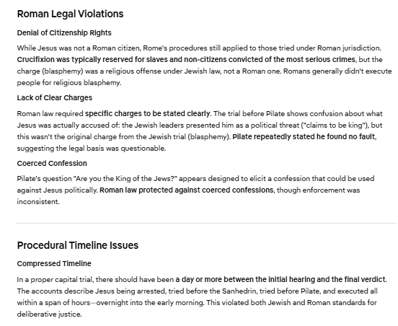
We are told that all things are good for those who are called according to God’s purposes. Peter was allowed to utterly fail in the key leadership moment and play the role of a coward. Jesus restored him after he learned that he was nothing without God’s help. This arrest was ultimately an indictment of the religious establishment and the Sanhedrin (Supreme Court of Israel).

