Exodus 40
God has been trying to connect with man since the beginning. An intimate and passionate relationship is the best and most satisfying. Those who earnestly seek God in that way will live that way in heaven forever. Unfortunately, man has always wanted another option; and a more open relationship. It is like the children’s book: Green Eggs and Ham. God has met the people wherever they were, spiritually. Today, we too can opt for a distant, 911 or grocery list relationship with God. That just needs-based and it is pretty independent. Unfortunately, that same separation level from God is void of spiritual power.
This is the end of the book of Exodus. Exodus began with the extraction of God’s people from a miserable life. It ends with the creation of an ongoing way to live under God’s rules instead of Pharaoh’s. This chapter is the commissioning and startup of all of the tabernacle activities, and priestly actions. Exodus is about the events that took place over one year. We are around 1491 BC.
Read Exodus 40:
What is the first day of the first month referenced here? Is it January 1st? No. God is starting the calendar all over again; now that he has started a new nation, Israel.
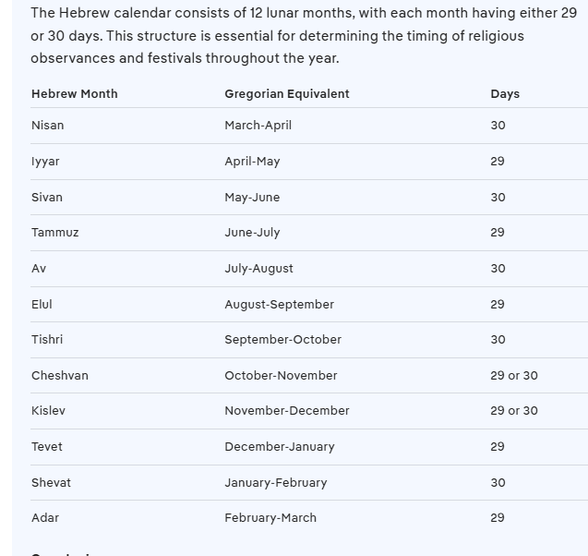
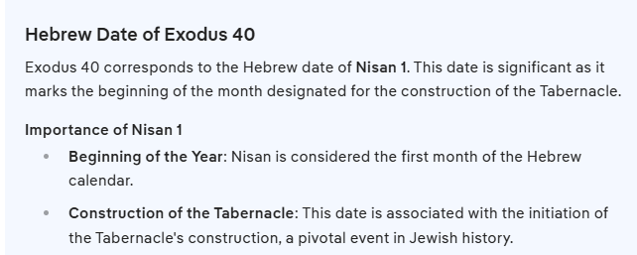
The bible says that we have to serve somebody. We can be slaves to sin, and be subjected to people like the heartless Pharaoh; or we can be willing servants of God. There is no 3rd option, of living as an independent. We are unknowingly owned by our natural drives unless God over-rides that.
Do you not know that the one to whom you present yourselves as slaves for obedience, you are slaves of that same one whom you obey, either of sin resulting in death, or of obedience resulting in righteousness? ¹⁷ But thanks be to God that though you were slaves of sin, you became obedient from the heart to that form of teaching to which you were entrusted, ¹⁸ and after being freed from sin, you became slaves to righteousness. (Romans 6)
People are fickle. The Hebrews cried out to God and begged him for deliverance in Egypt. They had become enslaved, and their boys were all killed. God supernaturally delivered them. The question is will they respond and follow their savior, or fall back into what had originally enslaved them? Will they look a gift horse in the mouth, and ignore their deliverer?
This chapter is the last part of God’s setup for a path to personal freedom. God used Moses to equip the priests to act as national intercessors. That intermediary fit their appetite for God. Some people still prefer that distance. Catholics want someone who knows God handling their business with God. Our heavenly citizenship is not based on being in good standing with like-minded people. Does God know us from us sharing our lives with him, and loving on him, or not?
The priests are now stepping in to do so. This was not God’s preferred method to live with men. God wants something that more closely resembles a good marriage. The Hebrews essentially elected Moses to handle all of their religious business. In other words, they did not really have an appetite for spiritual things….because they were still carnally minded.
Then they said to Moses, “Speak to us yourself and we will listen; but do not have God speak to us, or we will die!” (Exodus 20:19)
That arm’s length distance from God created a veil, or a barrier. God honored their desire to live their lives without always checking in with him. The further we become removed from God’s spirit, the more we fall back into the way of the world. There is no such thing as a moral independent. The long-term effects of distance from God is to fall back into the same enslavement to disillusion and defeat and hopelessness.
But their minds were hardened; for until this very day at the reading of the old covenant the same veil remains unlifted, because it is removed in Christ. ¹⁵ But to this day whenever Moses is read, a veil lies over their hearts; ¹⁶ but whenever someone turns to the Lord, the veil is taken away. (2 Corinthians 3)
The long-term result of putting personal freedoms over God’s direction is to put ourself in charge. We tend to think of freedom to make decisions as true freedom. Not so. We long for the very things that re-enslave us. Not loving God dearly comes off more robotic and mechanical. Our contact with God is needs based; rather than a personal preference.
One covenant is from Mount Sinai and bears children who are to be slaves: This is Hagar. ²⁵ Now Hagar stands for Mount Sinai in Arabia and corresponds to the present city of Jerusalem, because she is in slavery with her children. ²⁶ But the Jerusalem that is above is free, and she is our mother. ²⁷ For it is written: “Be glad, barren woman, you who never bore a child; shout for joy and cry aloud, you who were never in labor; because more are the children of the desolate woman than of her who has a husband.” ²⁸ Now you, brothers and sisters, like Isaac, are children of promise. ²⁹ At that time the son born according to the flesh persecuted the son born by the power of the Spirit. It is the same now. ³⁰ But what does Scripture say? “Get rid of the slave woman and her son, for the slave woman’s son will never share in the inheritance with the free woman’s son.” ³¹ Therefore, brothers and sisters, we are not children of the slave woman, but of the free woman. (Galatians 4)
We will see in the Book of Numbers that though God set up a plan…and an intercessor…they abandoned it altogether. God gave them what they wanted, fully knowing that was going to doom them all over again.
³⁵ “This Moses whom they disowned, saying, ‘Who made you a ruler and a judge?’ is the one whom God sent to be both a ruler and a deliverer with the help of the angel who appeared to him in the thorn bush. ³⁶ This man led them out, performing wonders and signs in the land of Egypt and in the Red Sea, and in the wilderness for forty years. ³⁷ This is the Moses who said to the sons of Israel, ‘God will raise up for you a prophet like me from your countrymen.’ ³⁸ This is the one who was in the assembly in the wilderness together with the angel who spoke to him at length on Mount Sinai, and who was with our fathers; and he received living words to pass on to you. ³⁹ Our fathers were unwilling to be obedient to him; on the contrary they rejected him and turned back to Egypt in their hearts, ⁴⁰ saying to Aaron, ‘Make us a god who will go before us; for this Moses who led us out of the land of Egypt—we do not know what happened to him.’ ⁴¹ At that time they made a calf and brought a sacrifice to the idol, and were rejoicing in the works of their hands. ⁴² But God turned away and gave them over to serve the heavenly lights; as it is written in the book of the prophets: ‘You did not offer Me victims and sacrifices for forty years in the wilderness, did you, house of Israel? ⁴³ You also took along the tabernacle of Moloch and the star of your god Rompha, the images which you made to worship. I also will deport you beyond Babylon.’ (Acts 7)
How could the people have done better in drawing close to God? Before the tabernacle was built, God met with Moses…and anybody else personally at the Tent of Meeting outside of the camp. Eventually the tabernacle became the tent of meeting.
⁷ Now Moses used to take a tent and pitch it outside the camp some distance away, calling it the “tent of meeting.” Anyone inquiring of the Lord would go to the tent of meeting outside the camp. ⁸ And whenever Moses went out to the tent, all the people rose and stood at the entrances to their tents, watching Moses until he entered the tent. ⁹ As Moses went into the tent, the pillar of cloud would come down and stay at the entrance, while the Lord spoke with Moses. ¹⁰ Whenever the people saw the pillar of cloud standing at the entrance to the tent, they all stood and worshiped, each at the entrance to their tent. ¹¹ The Lord would speak to Moses face to face, as one speaks to a friend. Then Moses would return to the camp, but his young aide Joshua son of Nun did not leave the tent. (Exodus 33)

